DOCUMENTATION
ON
GITHUB

Date Presented by
27-9-2021 Srinidhi Yadla

Table of contents

Installation of Github on Windows.......................................................i
Launching Git on Windows..................................................................ii
Creating a Github Account...................................................................iii
Creating a Repository...........................................................................iv
Cloning Github repository using Gitbash in windows..........................v
Cloning Github repository from Eclipse..............................................vi

Performance of Pull Operation in Eclipse...........................................vii

Synchronize the local repository with Github....................................viii

Installation of Github on Windows

Step 1 : Navigate to the download page of official git website
https://gitforwindows.org download Git client for windows.

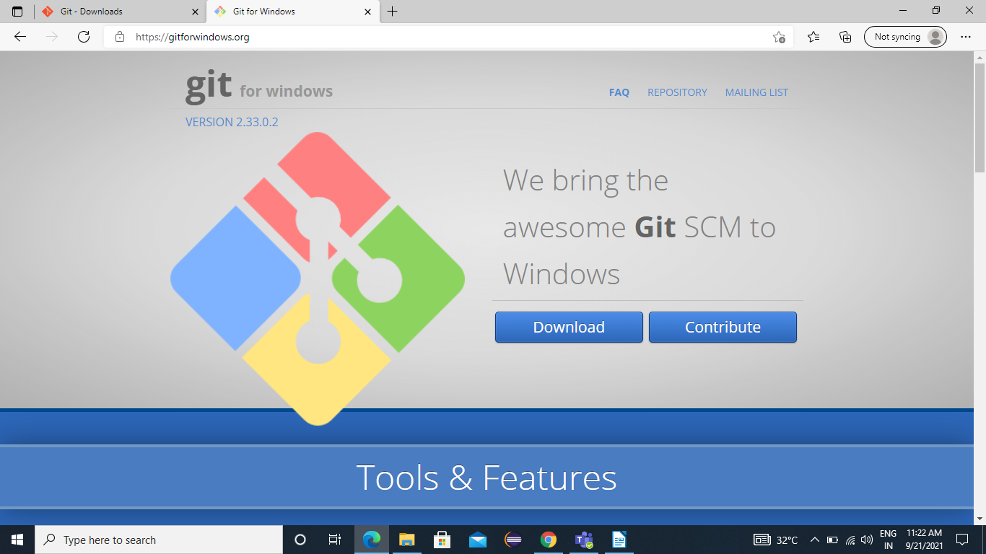
Step 2: Browse to the download location (or use the download shortcut in your browser ). Double-click the file to extract and launch the installer.
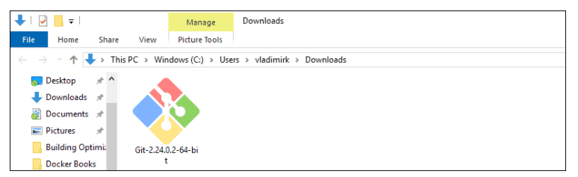
Step 3: Allow the app to make changes to the device by clicking yes on the User Account Control dialog that opens.
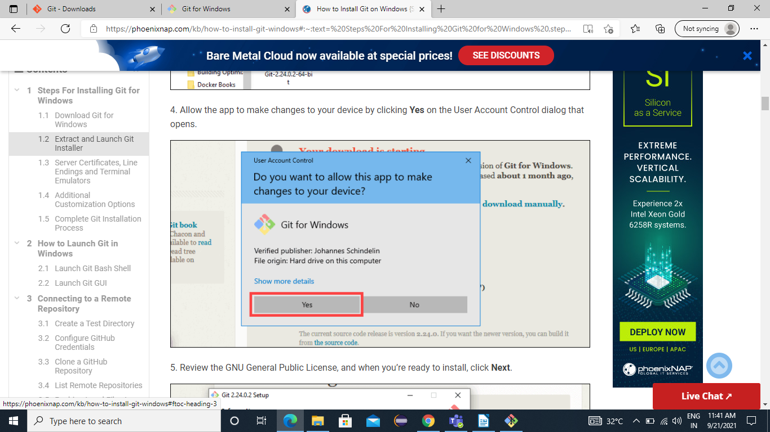

Step 4: Review the GNU General Public License and when you are ready to install click on Next.
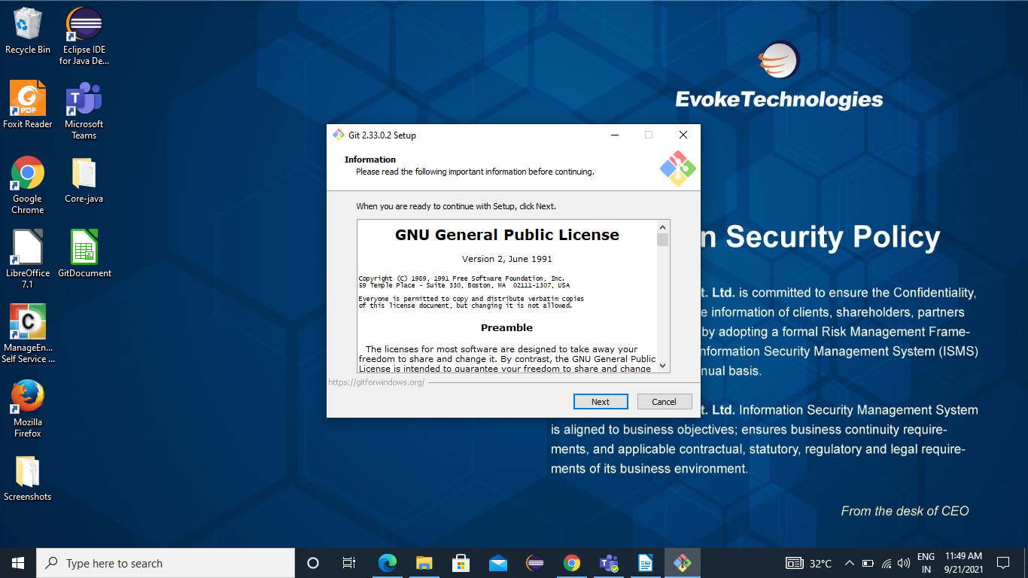

Step 5: A component selection screen will appear. Leave the defaults unless you have a specific need to change them and click on next.

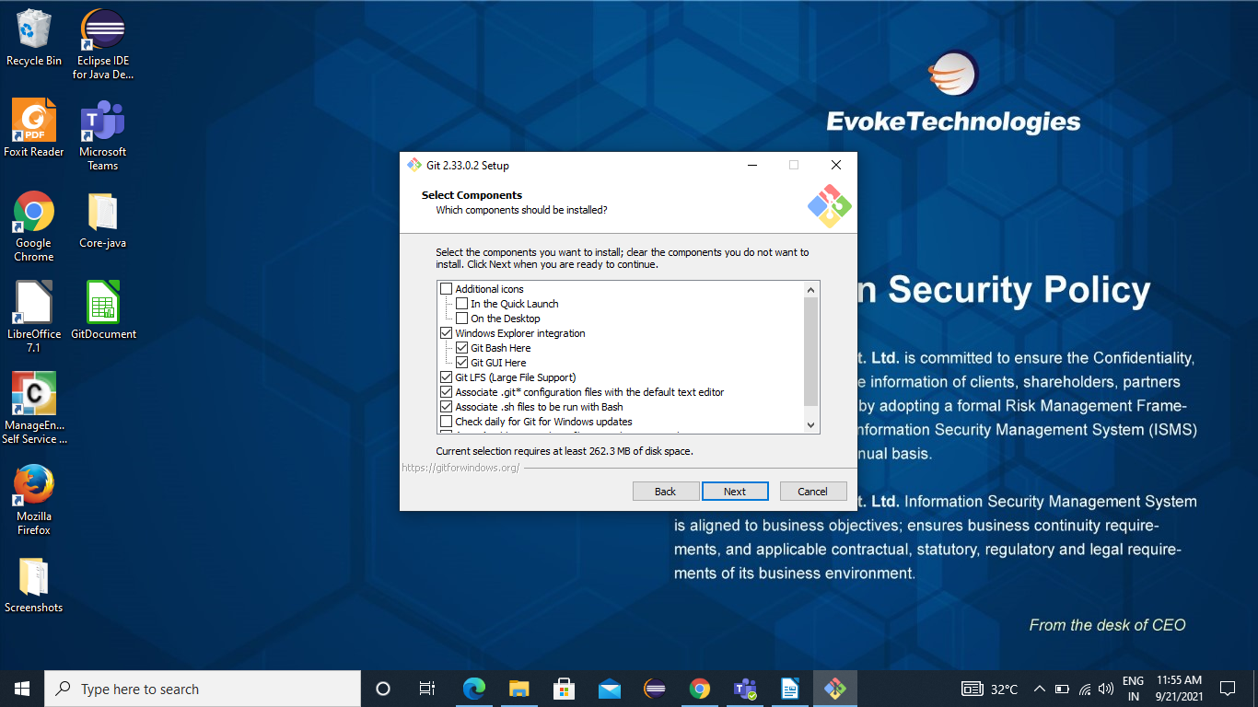

Step 6: Select a text editor you would like to use with the Git. Use the drop-down menu to select Notepad++ (whatever text you prefer) and click on Next.

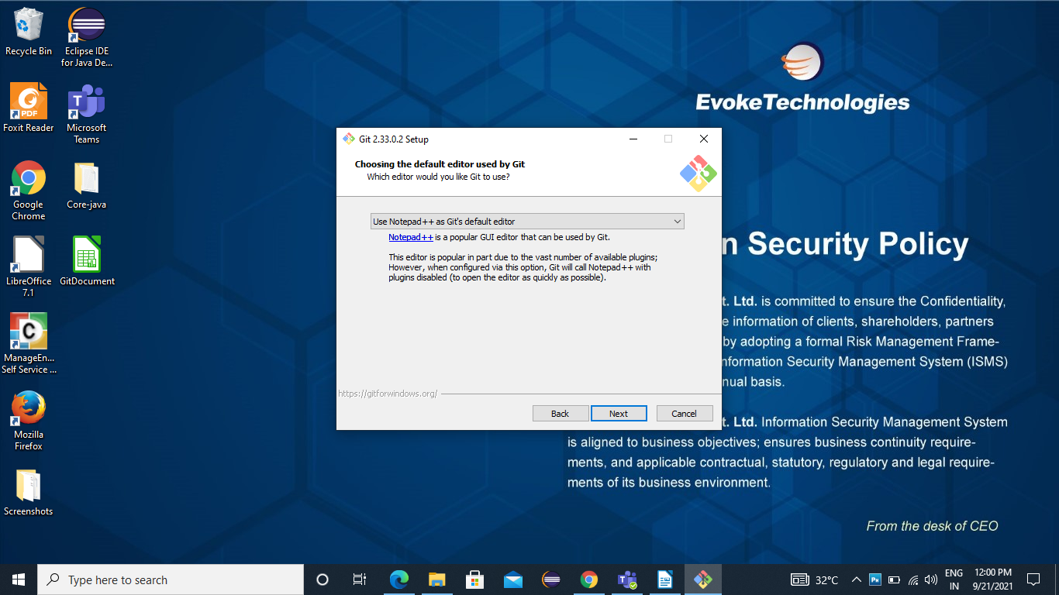

Step 7: Next is to adjust the name of the initial branch in new repositories. Here the default is “Master”. Unless you require a different name, leave the default option and click on Next.
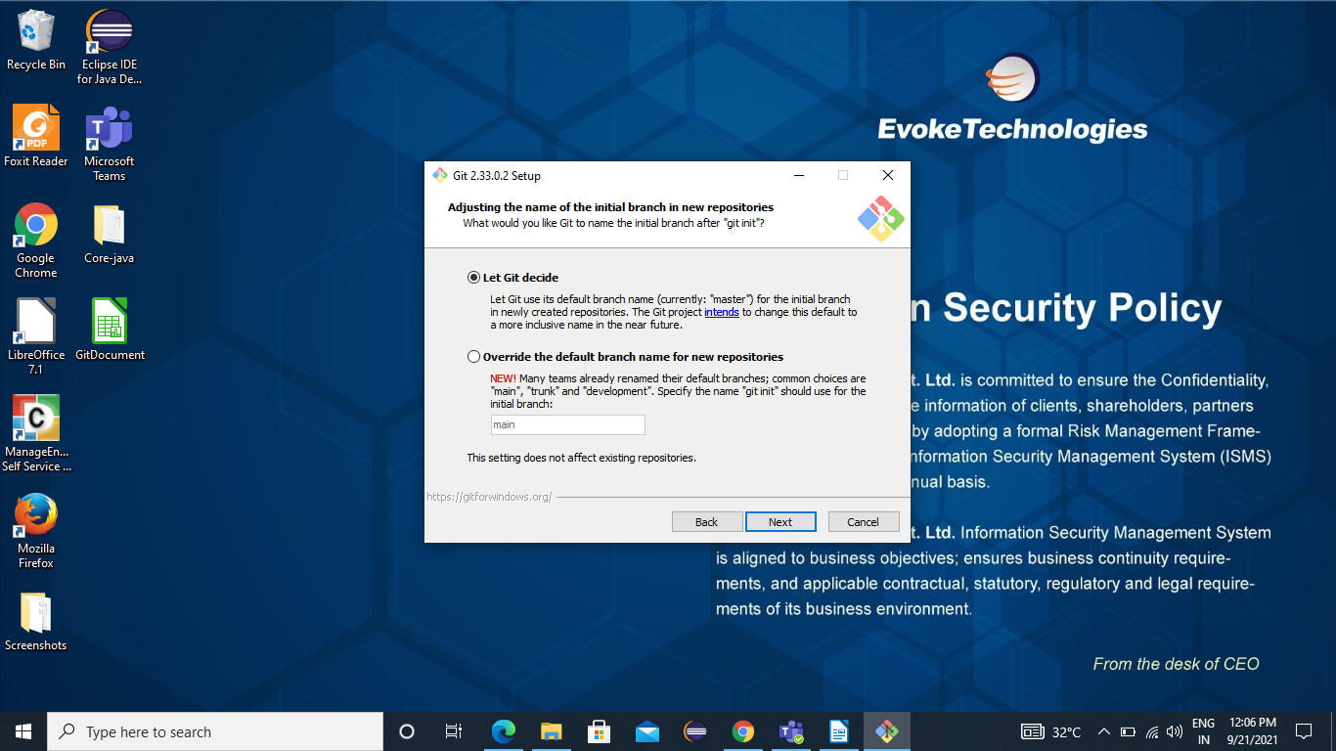

Step 8: Here adjusting your PATH environment. The PATH is the default set of directories included when you run a command from the command line. So leave the recommended selection and click on Next.
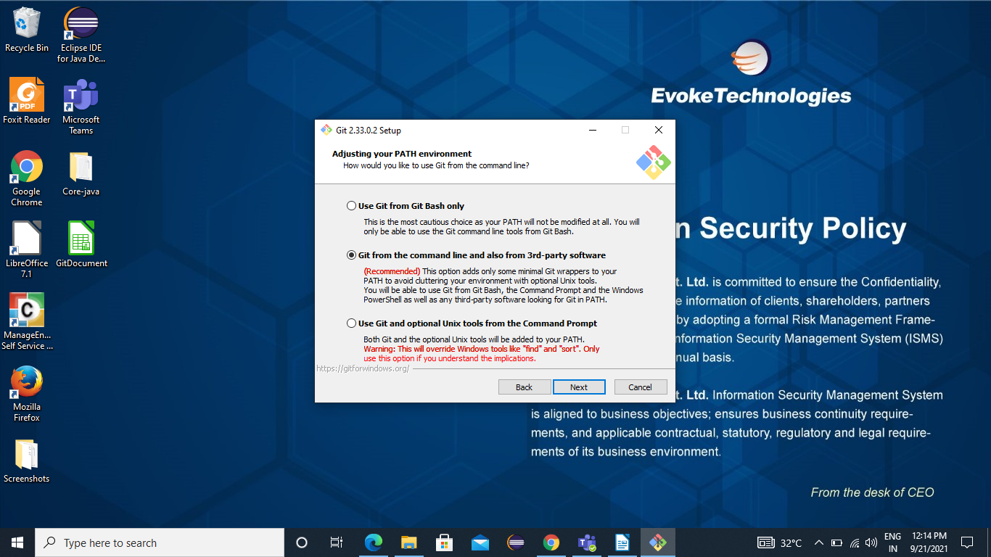

Step 9: The installer now asks which secure shell client program would you like git to use. So Git already comes with its own SSH client, so if you don’t need a specific one leave it as default option and click on Next.
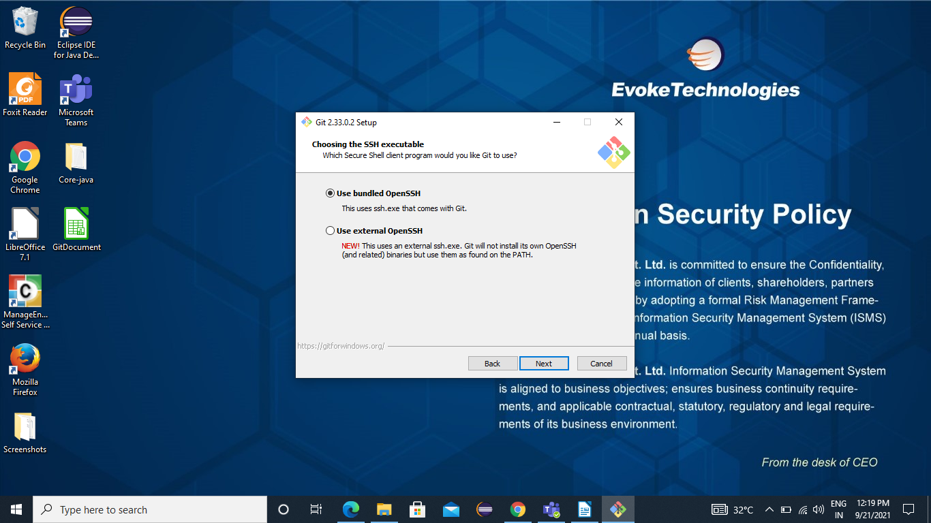

Step 10: The next option relates to server certificates. Most users should use the default. If you are working in an Active Directory environment, you may need to switch to windows store certificates and click on Next.
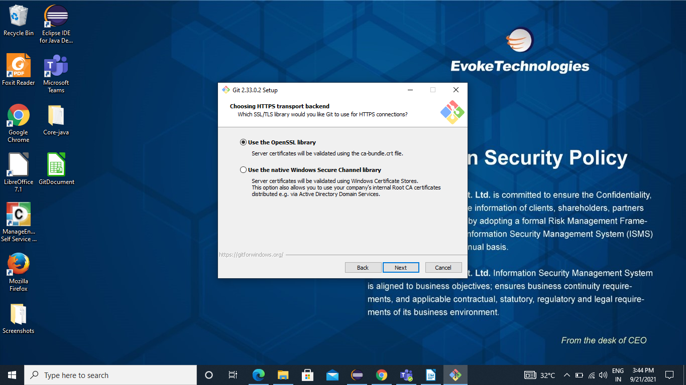

Step 11: The next selection converts line endings. It is recommended that you leave the default selection. This relates to the way data is formatted and changing this option may cause problems and click on Next.
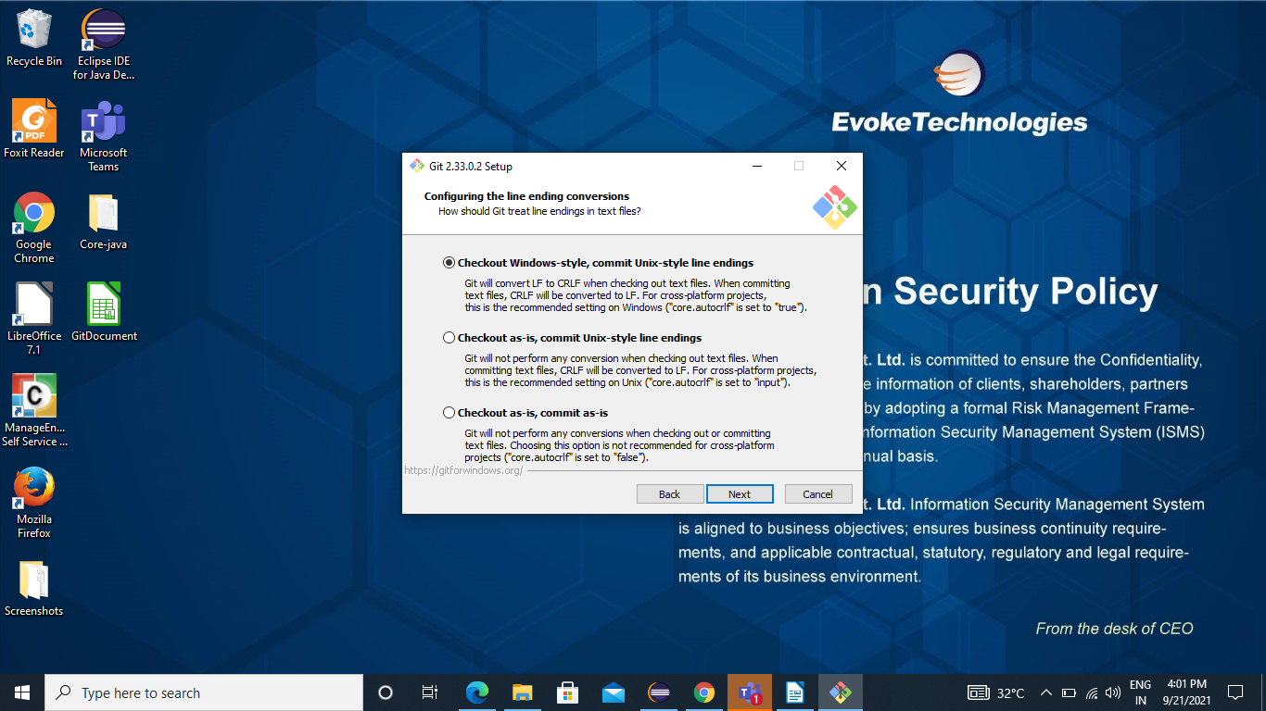

Step 12: Choose the terminal emulator you want to use. The default MinTTY is recommended for it features and Click on Next.

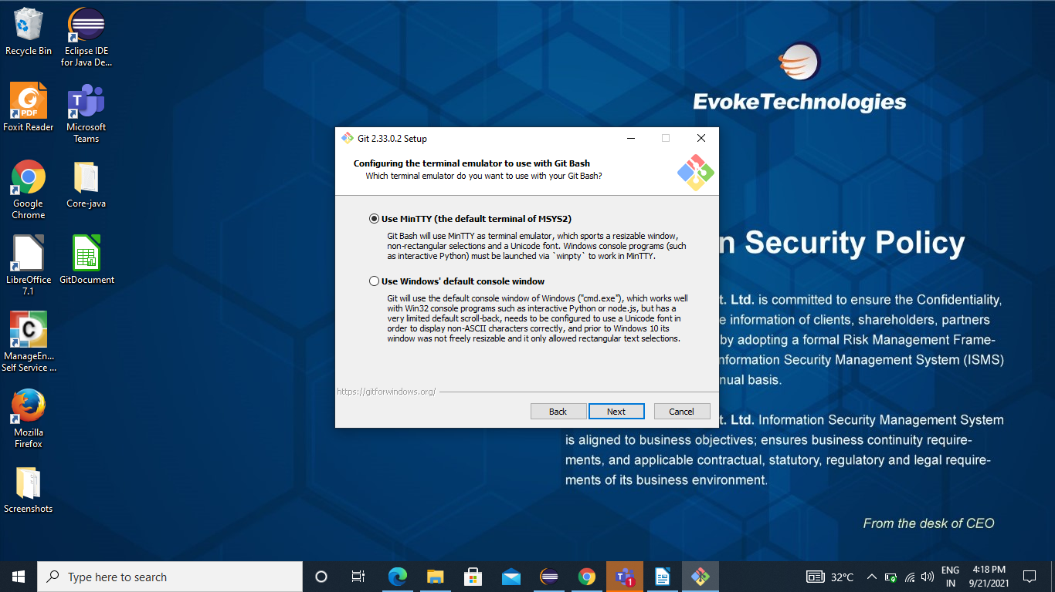

Step 13: Here the installer now asks what the Git Pull command should do. The default option is recommended unless you specifically need to change its behavior and click next to continue.

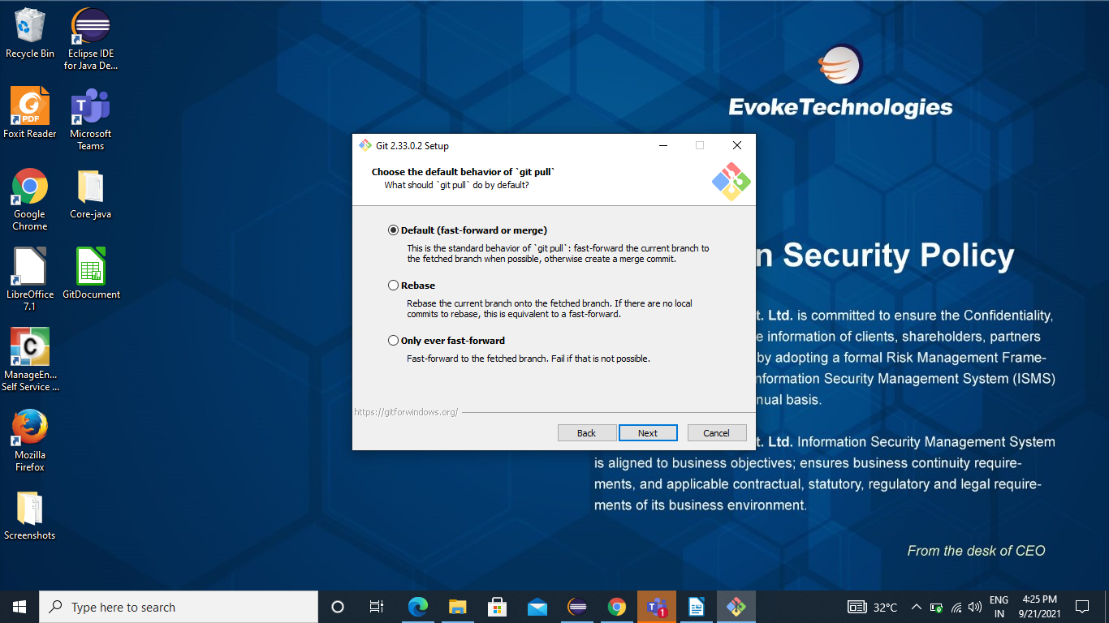

Step 14: Here we need to choose which credential helper to use. Git uses credential helper to fetch or save credentials so leave the default option and click Next.

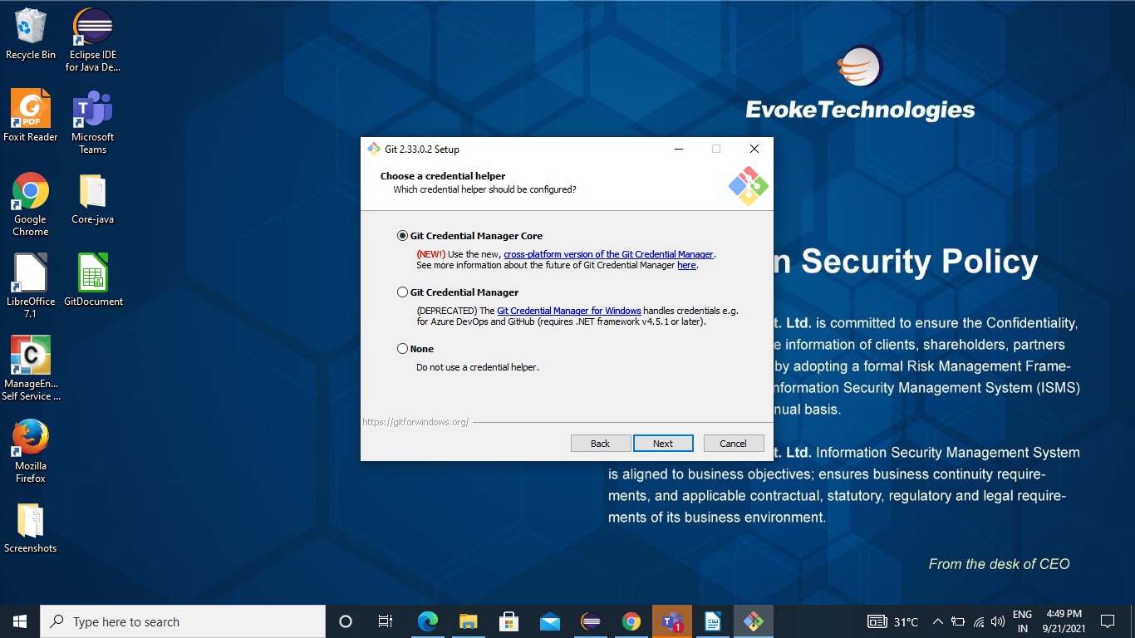

Step 15: The default options are recommended anyhow this step allows you to decide which extra option you would like to enable. So tick the box and click on next.
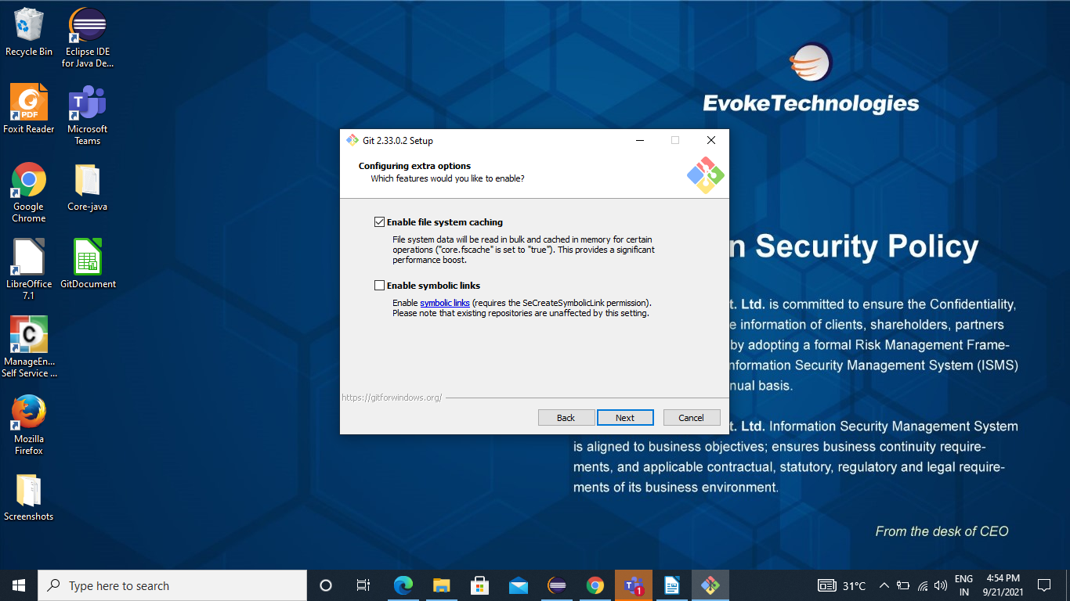

Step 16: Depending on the version of Git you are installing, it may offer to install experimental features. At the time this article was written, the options to include support for pseudo controls and a build in file system monitor were offered. Unless you are feeling adventurous, leave them unchecked and click on Install.

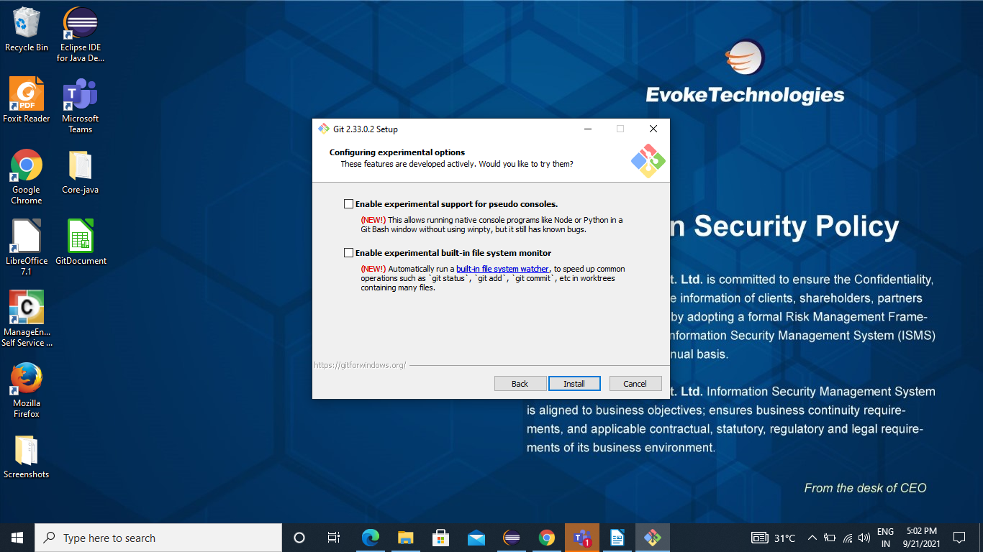

Step 17: Once the installation is complete, tick the boxes to view the release Notes or launch git bash and click Finish

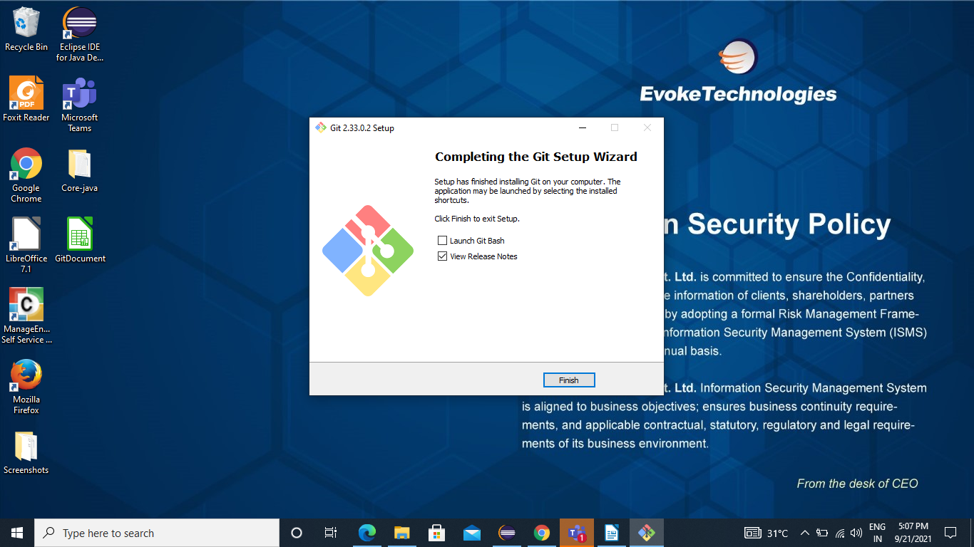

Launching Git on Windows
Step 1: To launch the Git Bash open windows start menu and type Git Bash and press enter.
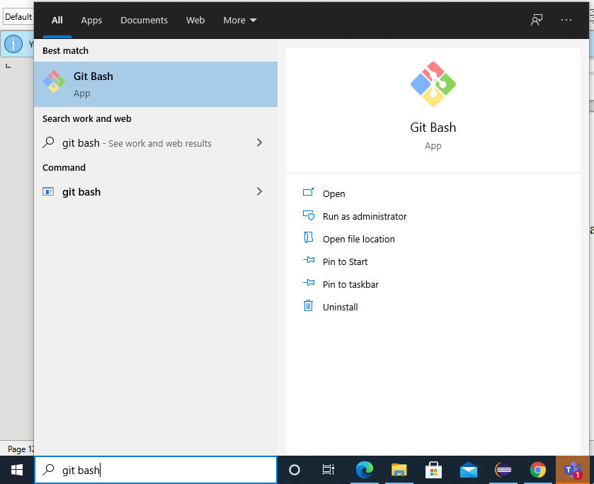

Step 2: To launch Git Gui open windows start menu and type git gui and press enter.
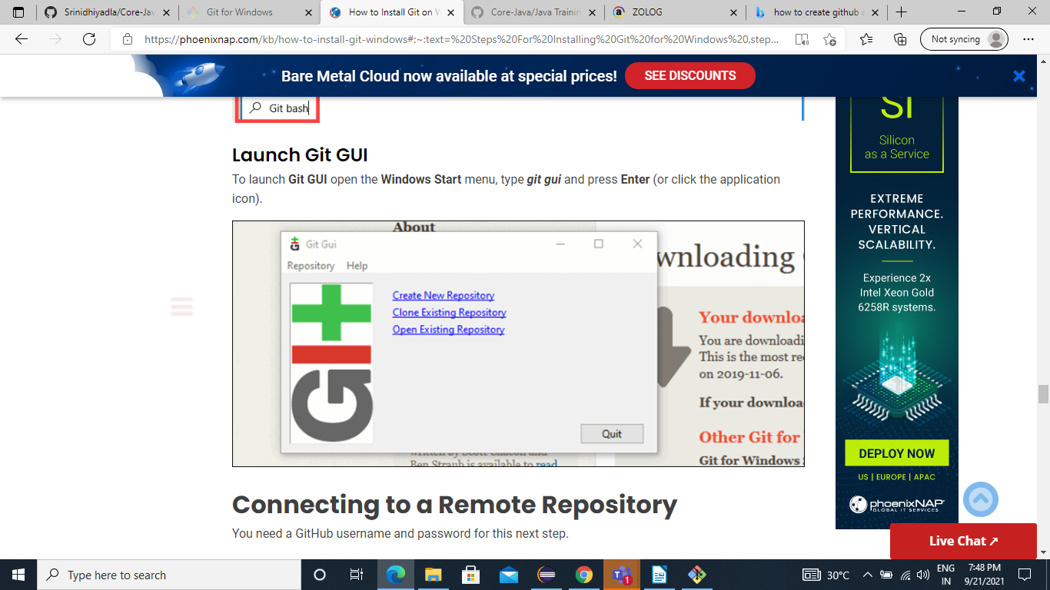

Creating a Github Account
Step 1: Go to GitHub.com and Click on We can see a Sign up option on right top corner of desktop


Step 2: Enter all your basic information like Username, Email address, Password for your account.
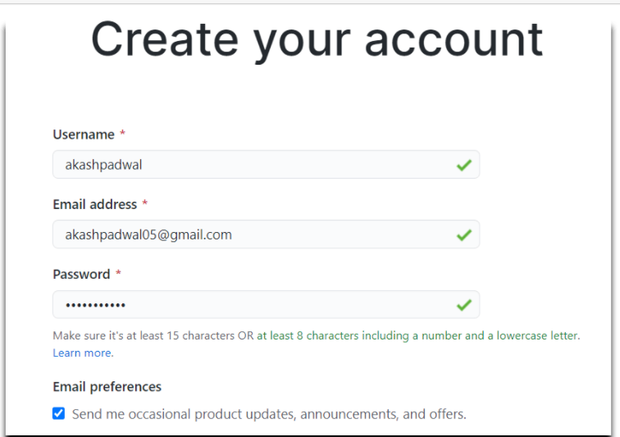

Step 3: Now verify your account by solving the puzzle or entering captcha and click on create account.
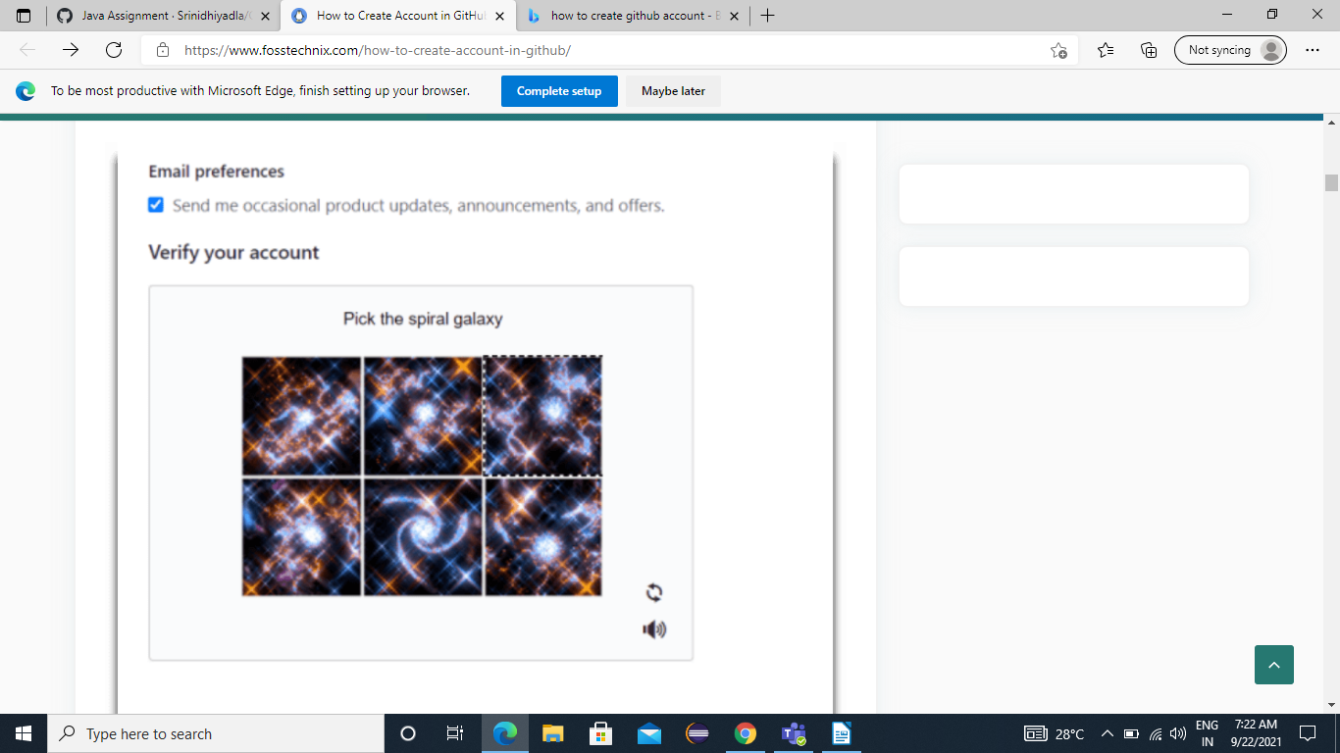

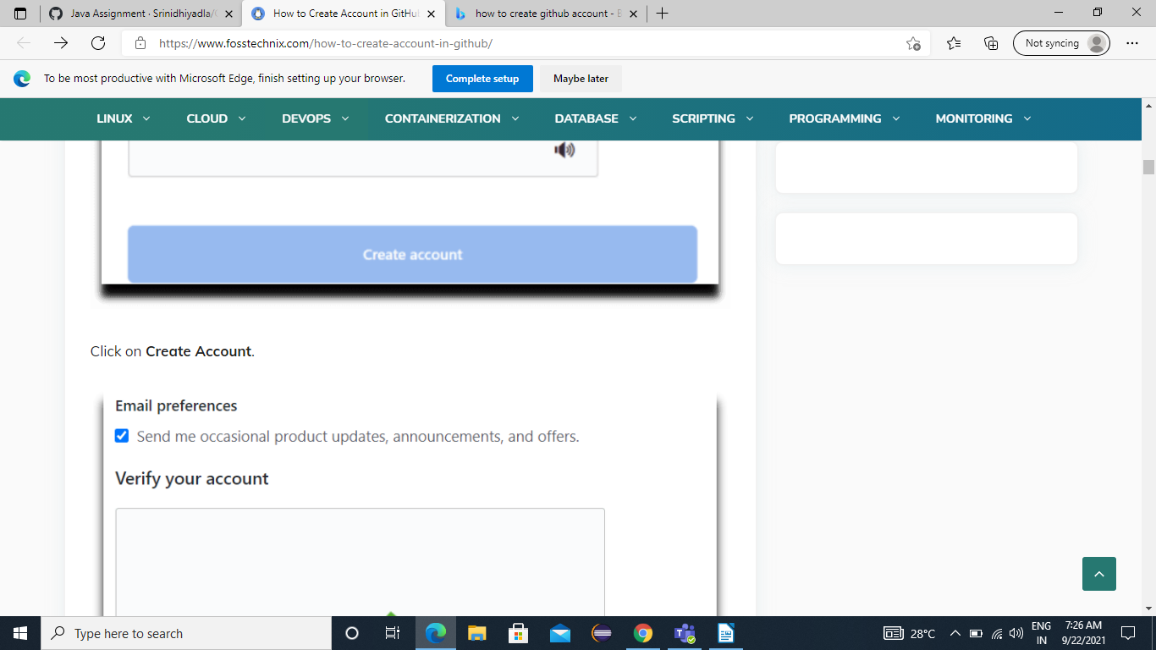

Step 4: This is the page it appears after creating the Github Account
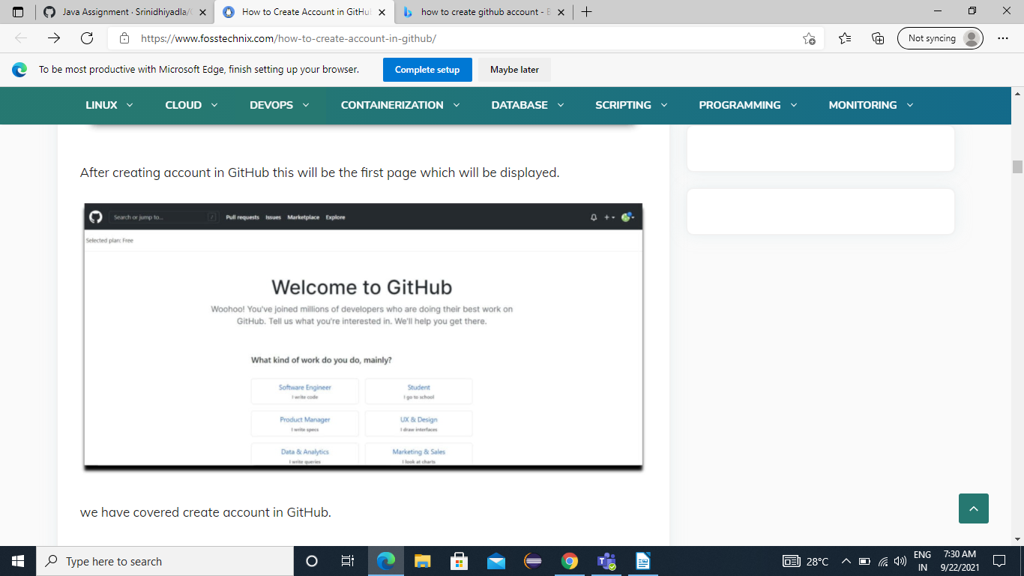

Creating a Repository in Github

Step 1: Here at top right corner of GitHub’s home page we can observe an add (+) button just have click on that and select “New Repository” option.
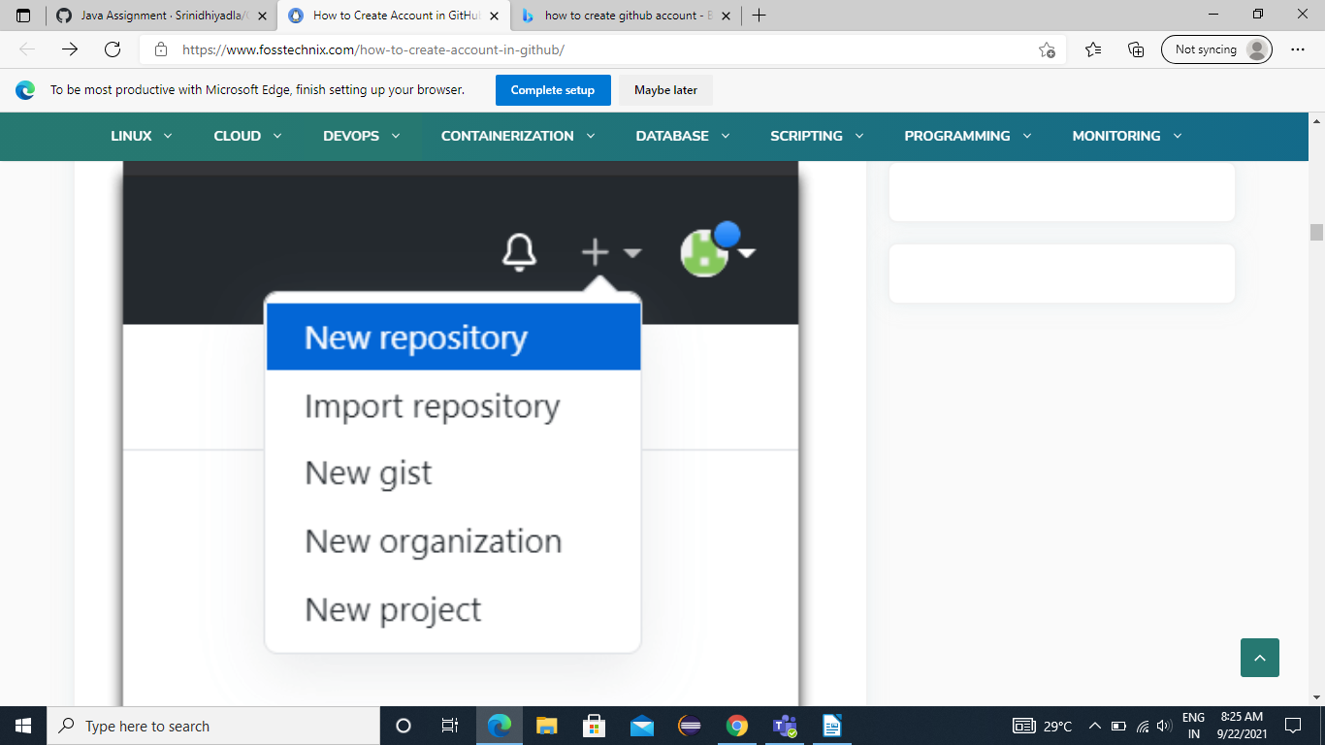

Step 2: The below page appears give a name for your repository for example “intern2021” and description can be optional so click on Create repository
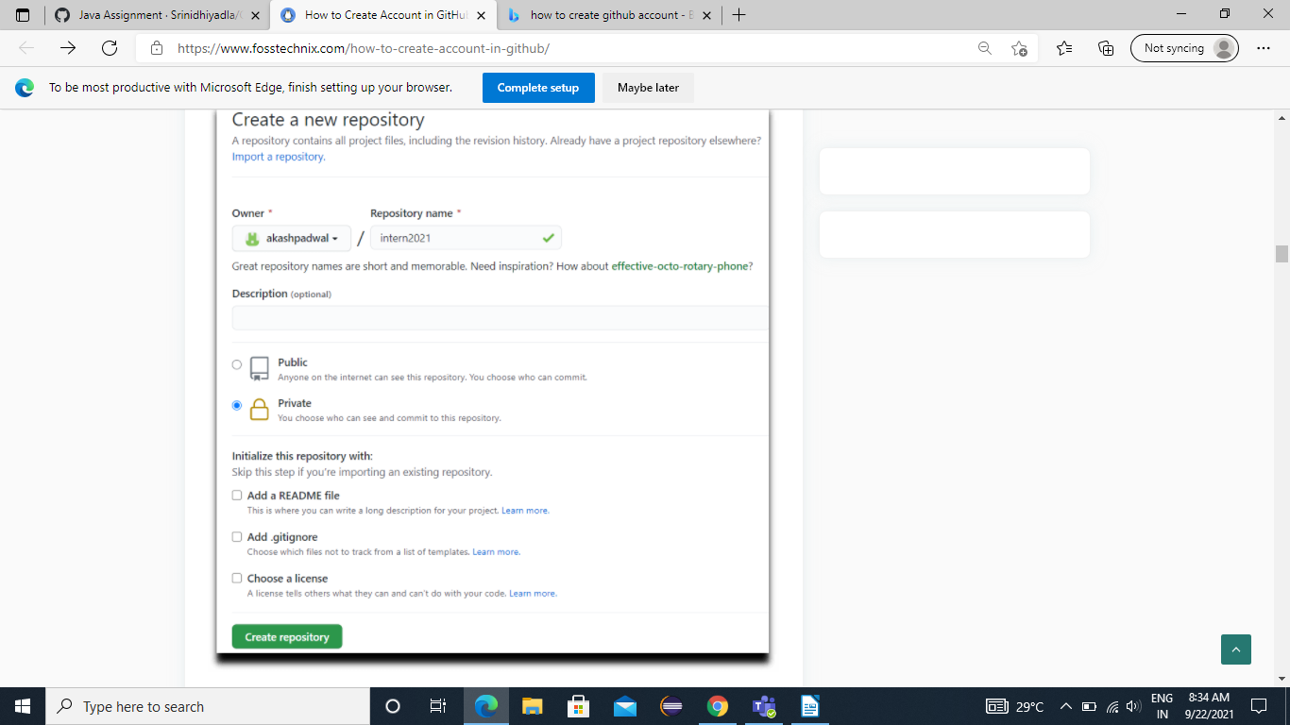

Step 3: Repository is created use below instructions on GitHub to create New repo on command line.
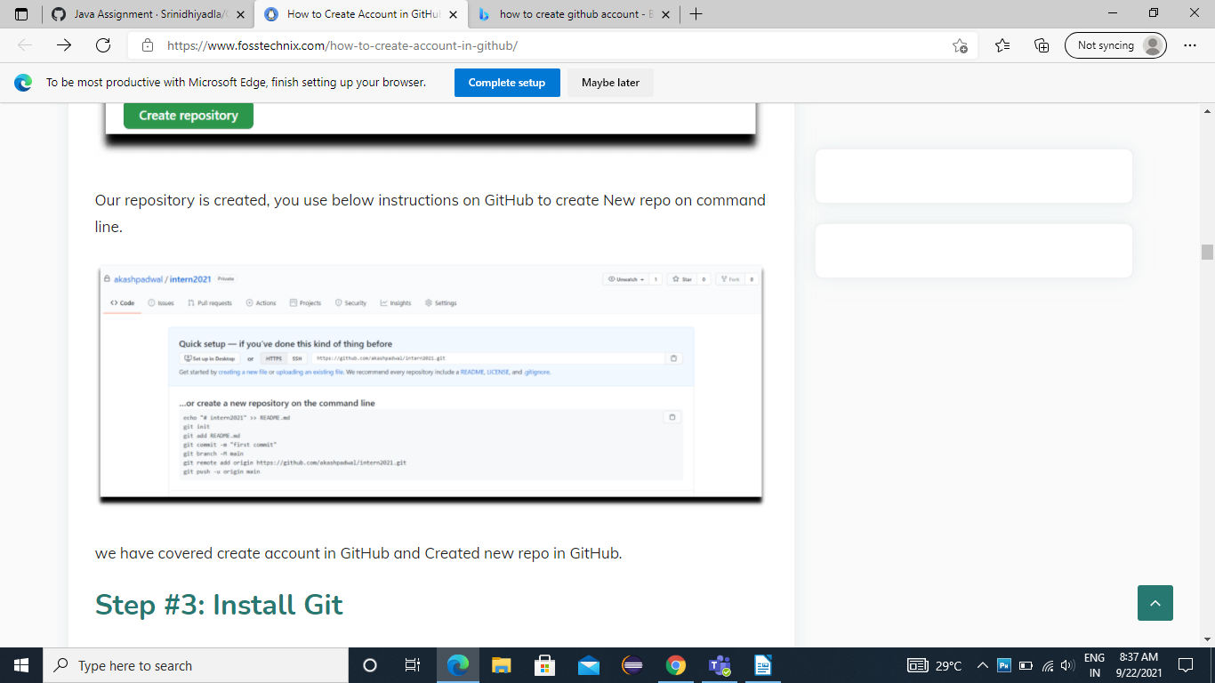

Cloning Github repository Using Gitbash in windows

Step 1: To Clone GitHub repository to local we need to Open a directory where you want to clone. So Open Git Bash option here.
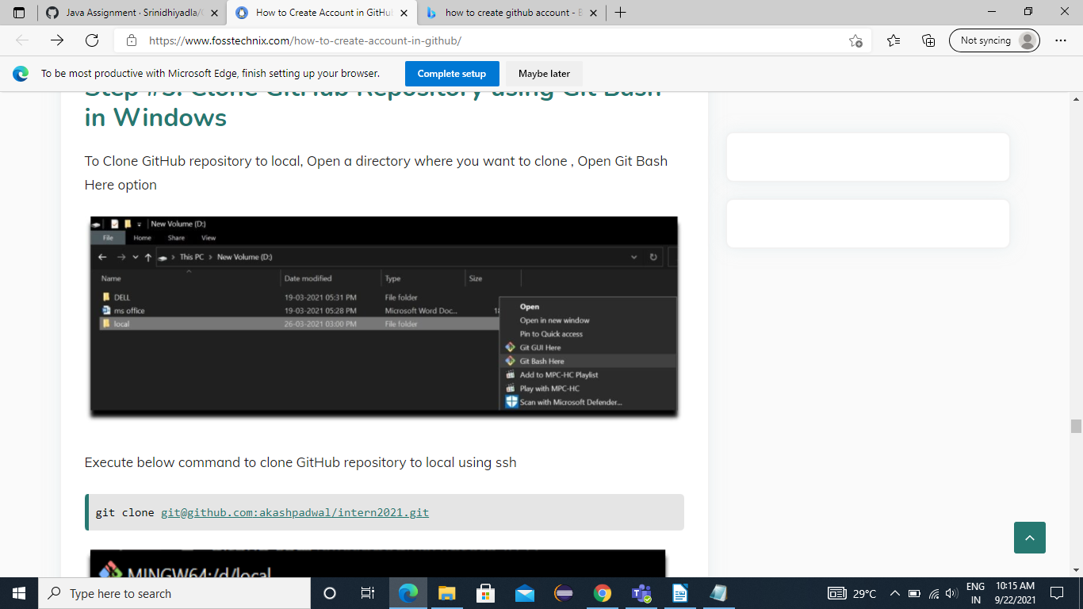

Step 2 : By executing below command to clone GitHub repository.
git clone - git@github.com:akashpadwal/intern2021.git
and click enter.
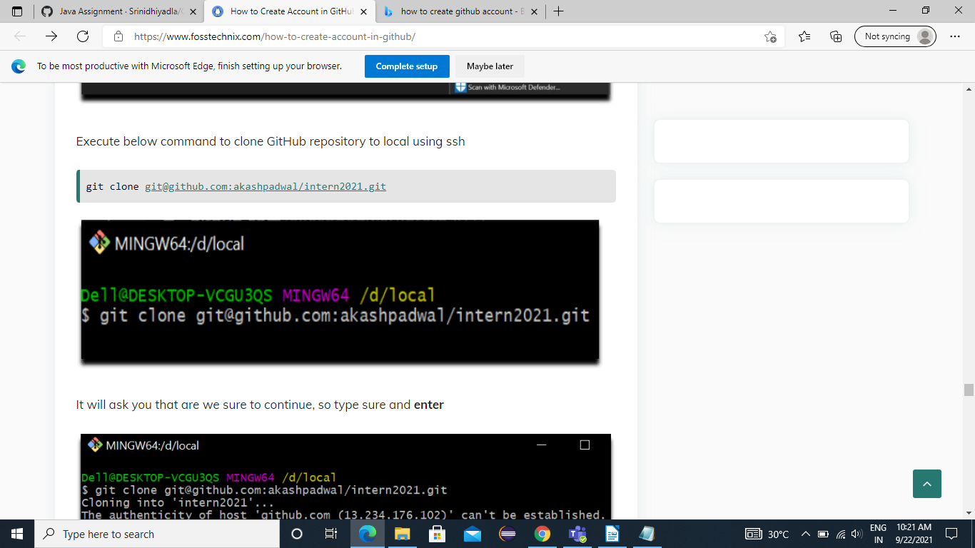

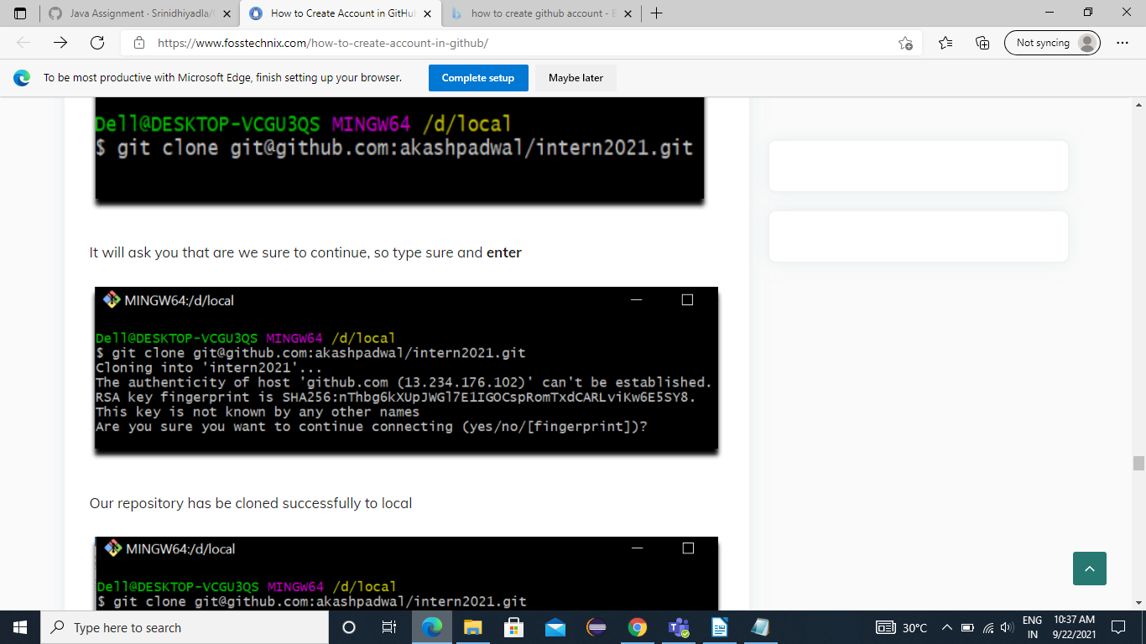

Step 3 : Repository has be cloned successfully to local
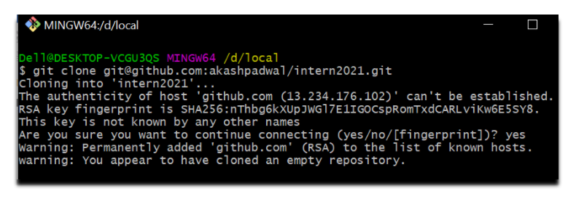

Step 4: Now we have to create a new branch for our repository by using the below command
git checkout -b <branch name>
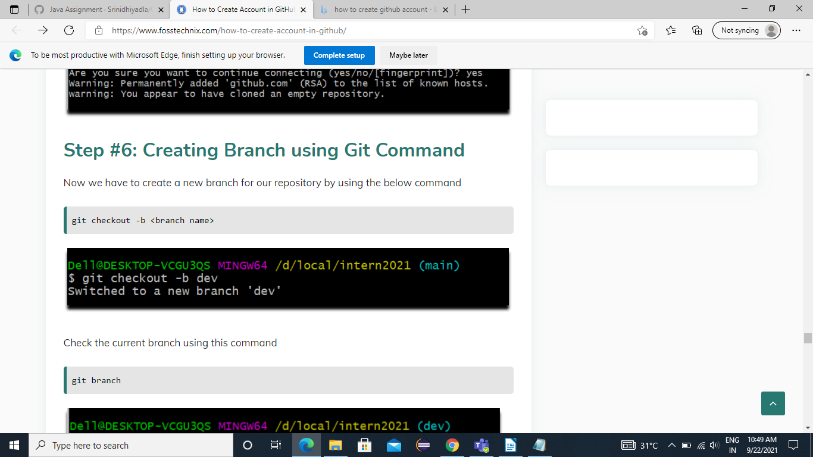

Step 5: Check the current branch using this command
git branch
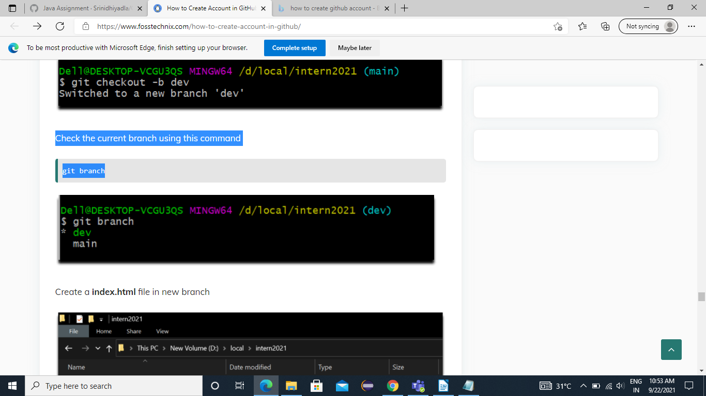
Step 6: Create a index.html file in new branch
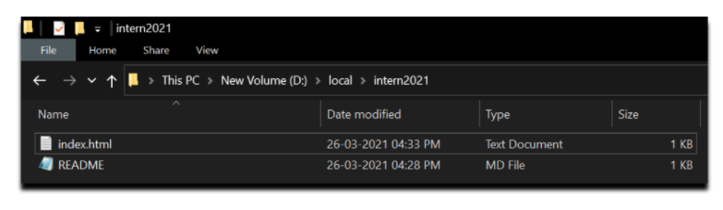

Step 7: Execute ls command to check current files in repository
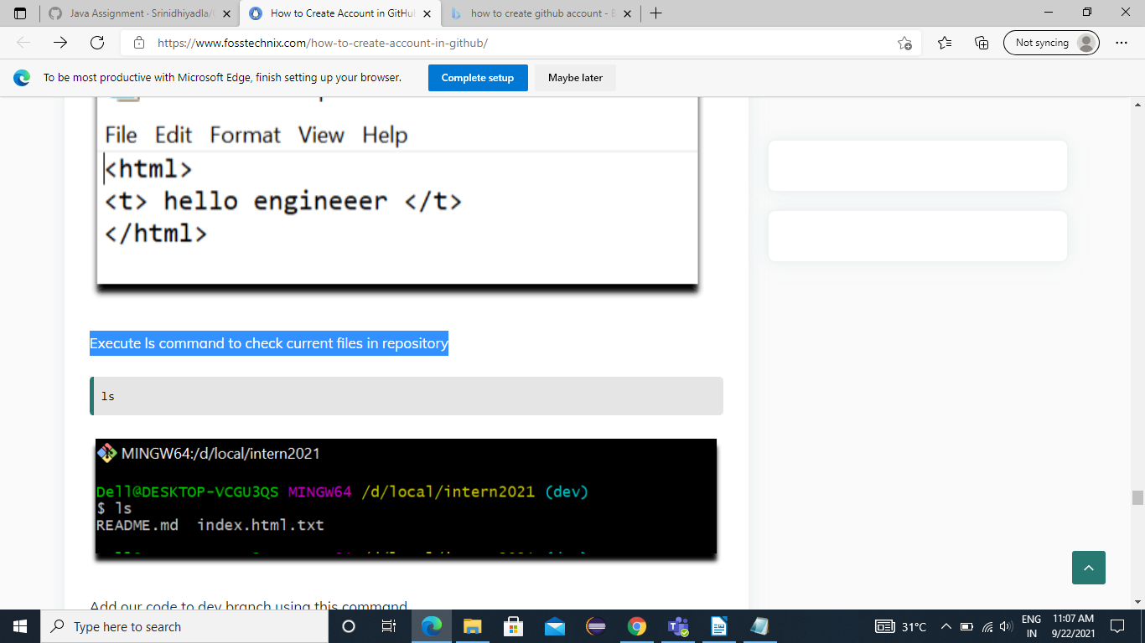

Step 8: Add our code to dev branch using this command
git add .
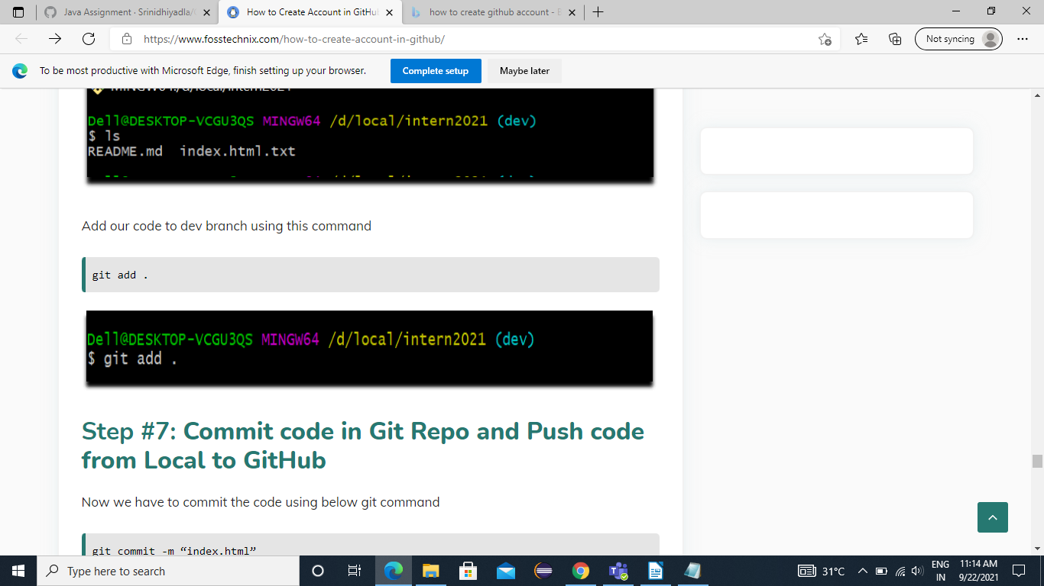

Step 9: Now we have to commit the code using below git command git commit -m “index.html” . The file that we created in our local and now we will commit it.
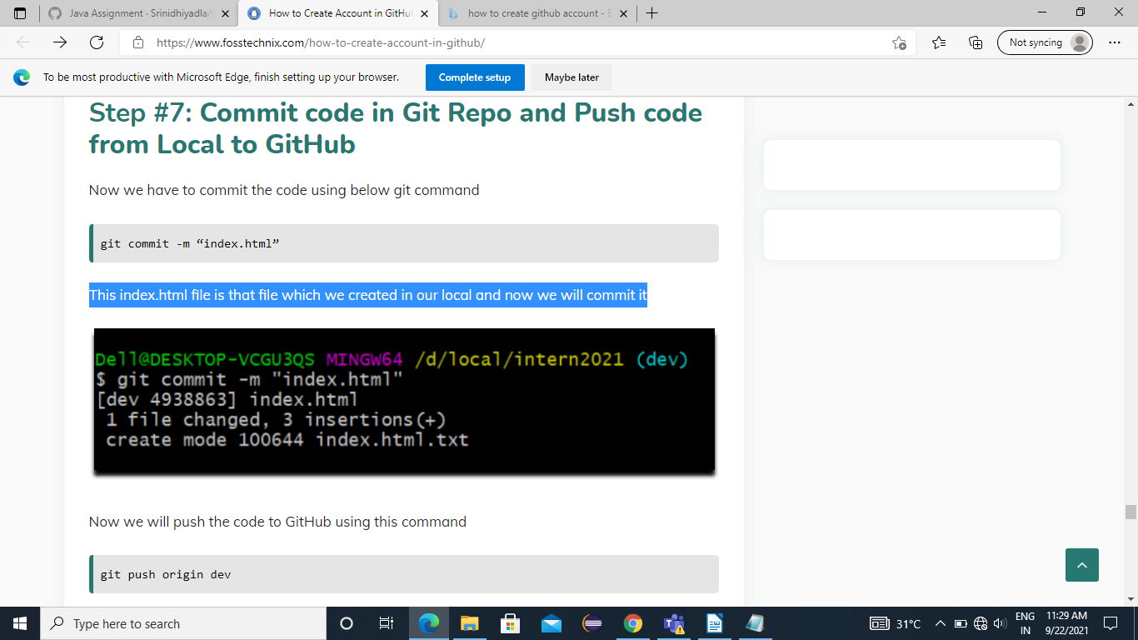

Step 10 : Now we will push the code to GitHub using this command
git push origin dev
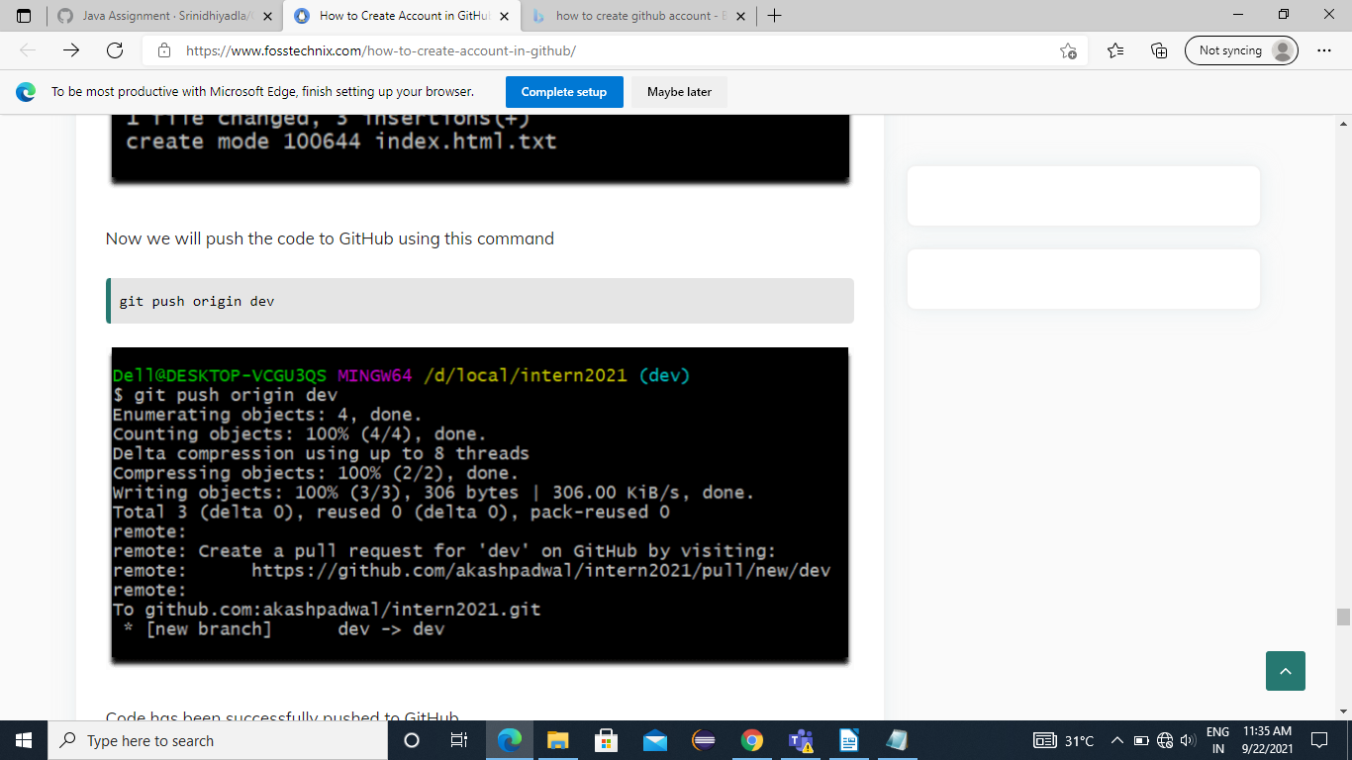

Step 11: Now we will merge the code from dev branch to main branch using below command.
git merge dev
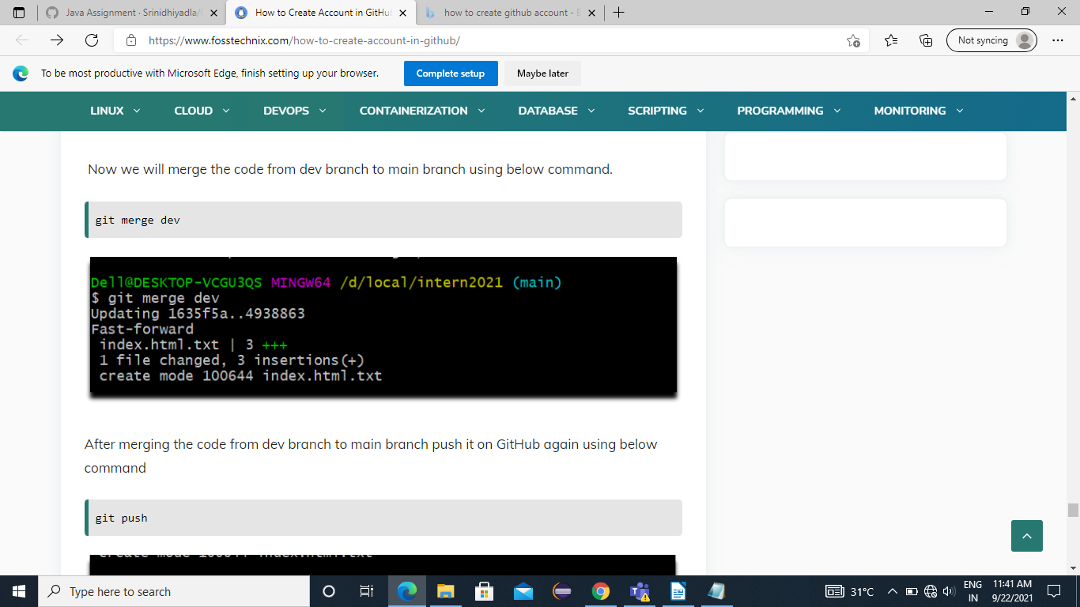

Step 12: After merging the code from dev branch to main branch push it on GitHub again using below command
git push
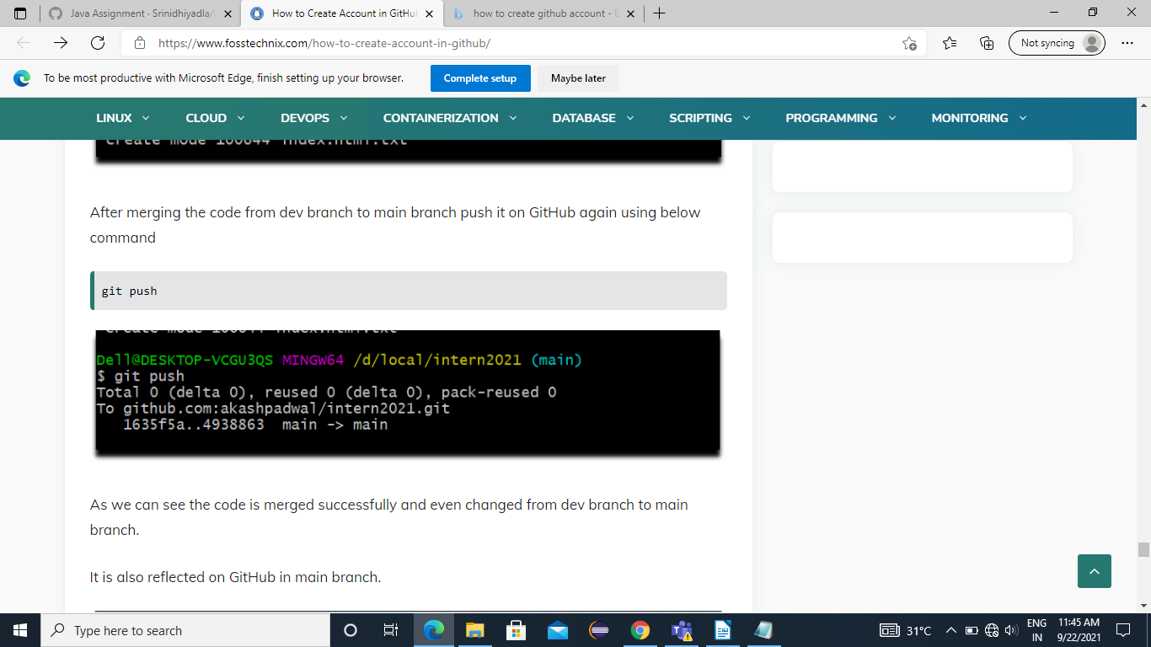

Step 13: As code is merged successfully GitHub is in main branch.
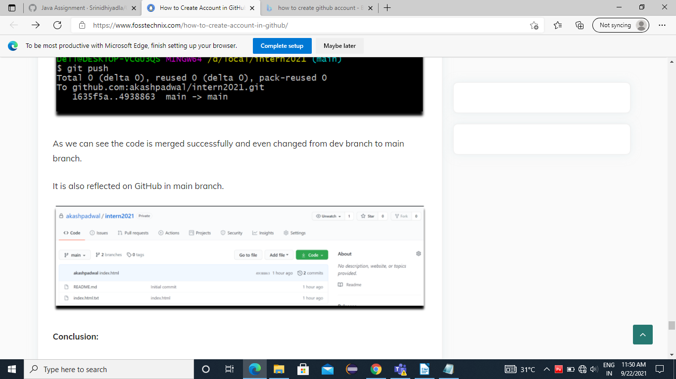

Cloning Github repository from Eclipse
Step 1: Click on windows< click on short view< select other.

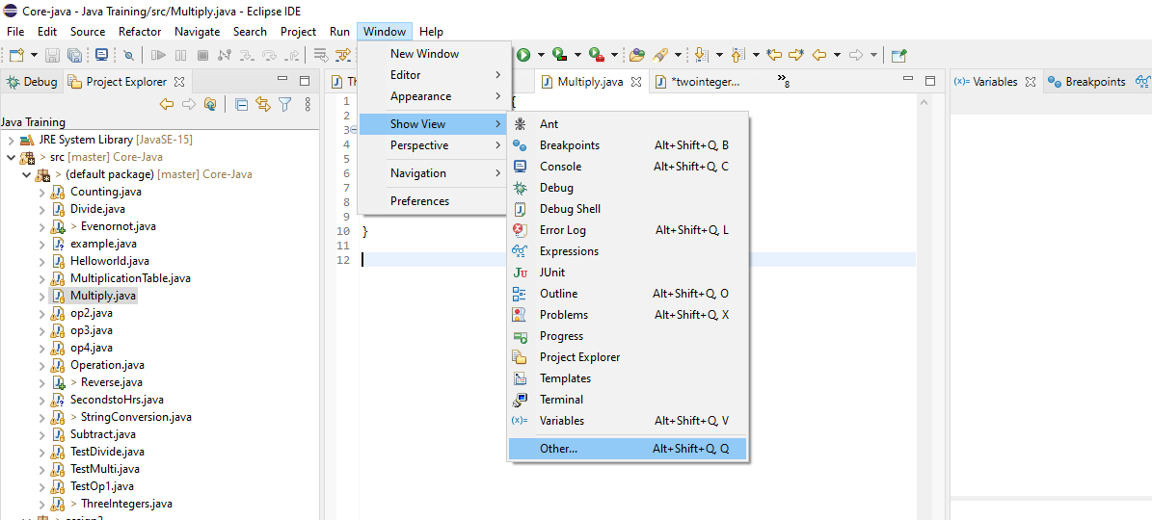

Step 2: now click on Git repositories and open.
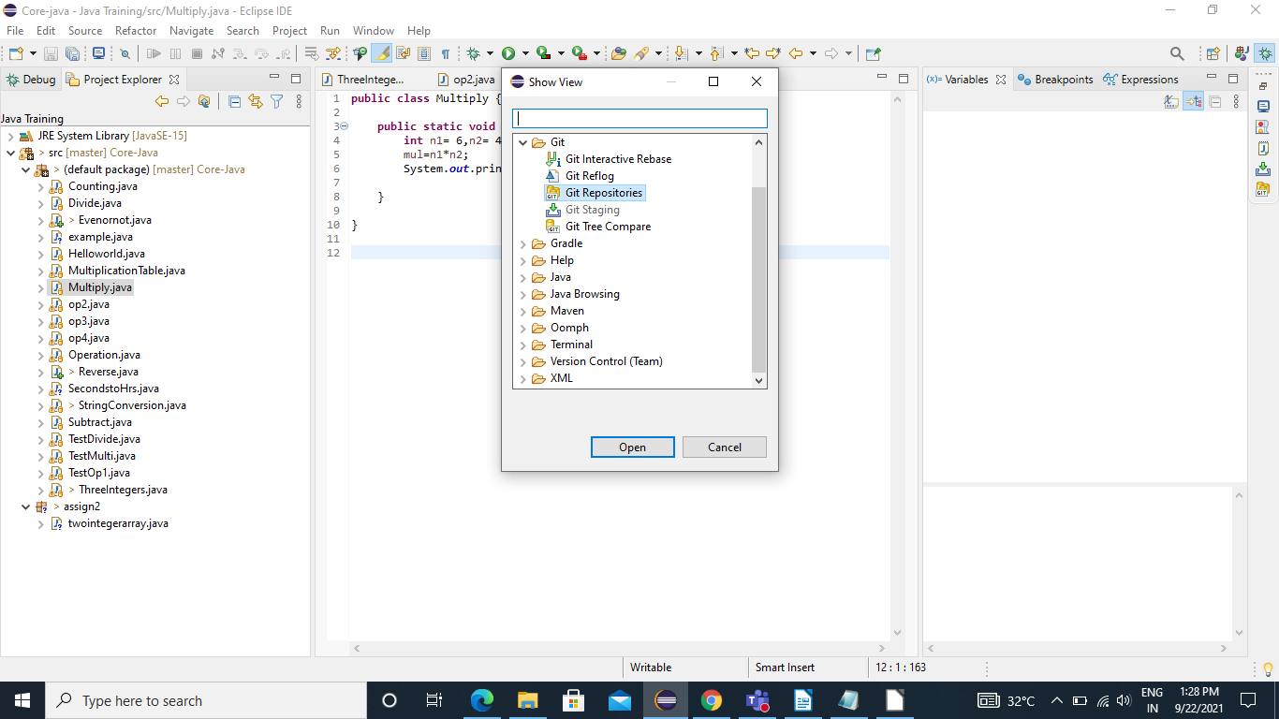

Step 3: Right click on the project folder, select Team > Share Project.
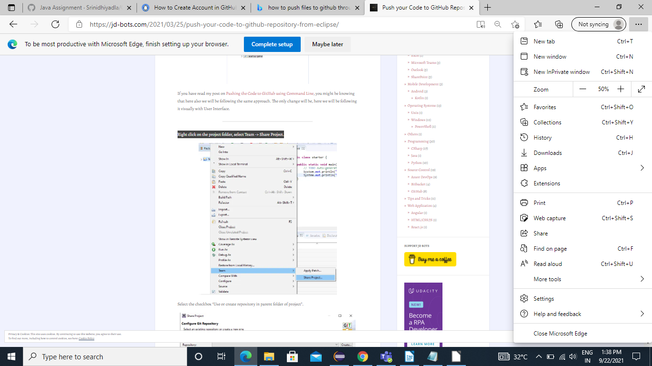

Step 4: Select the checkbox - Use or create repository in parent folder of project
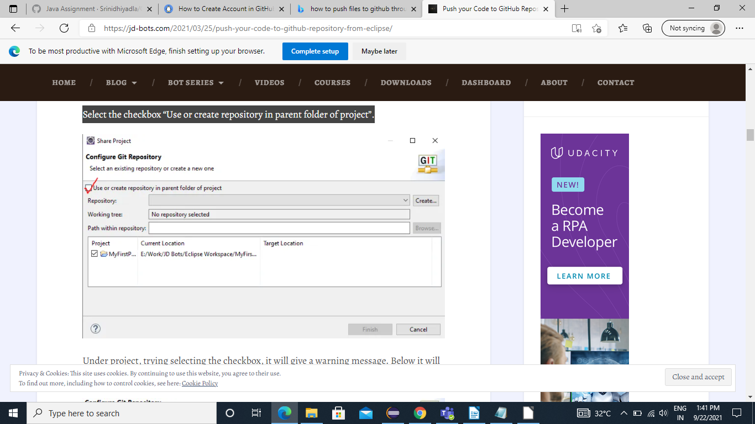

Step 5: Under the project select the checkbox and it will give a warning message. Then below it will ask to create repository.
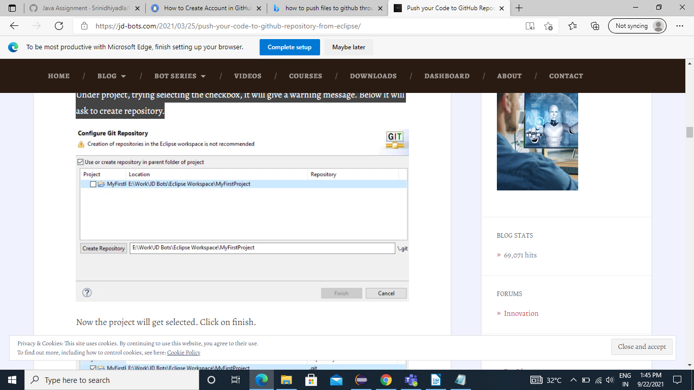

Step 6: Now the project will get selected. Click on finish.
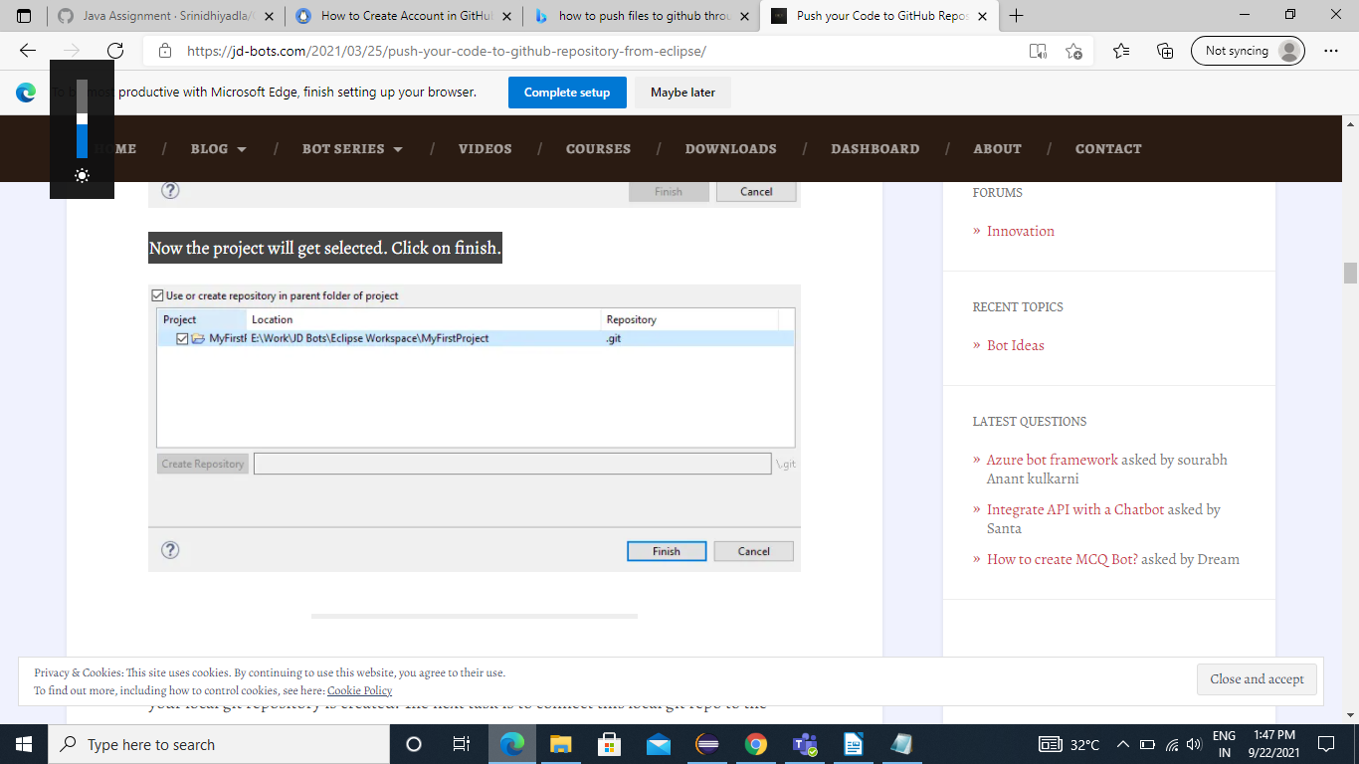

Step 7: Initially, changes are in Unstaged Changes. This has to be moved to Staged changes before Commit.
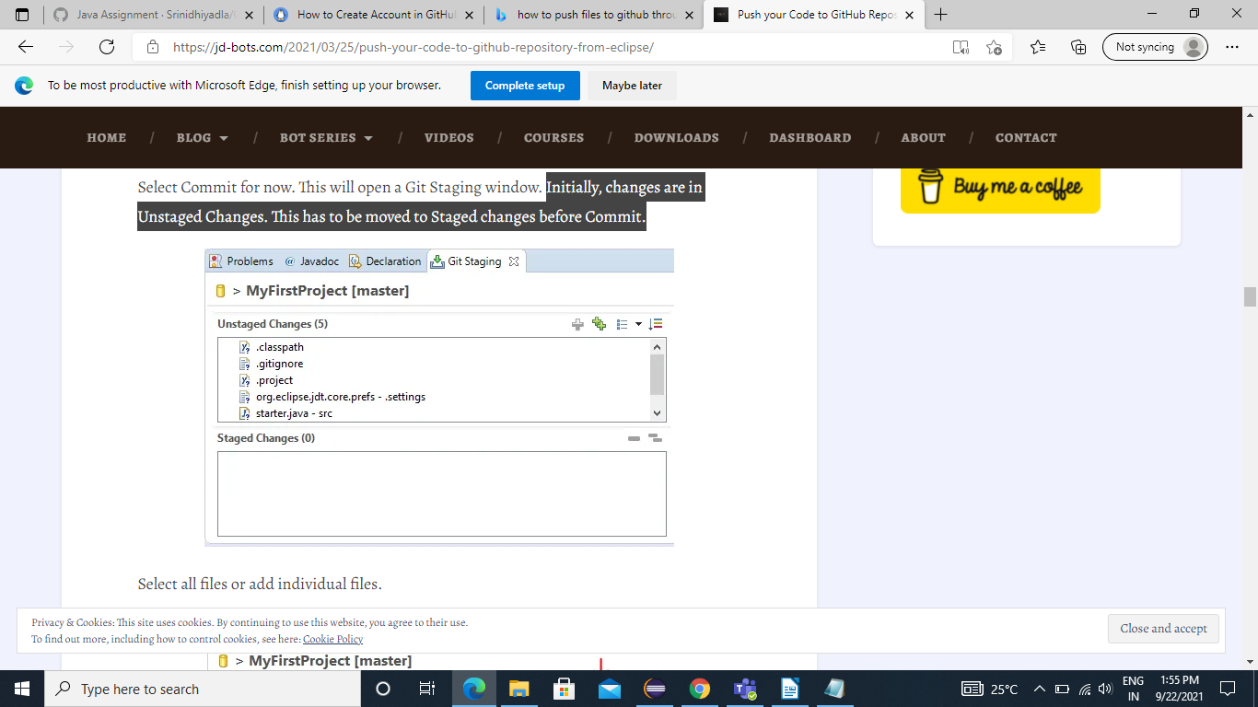

Step 8: Select all files or indiviual files.
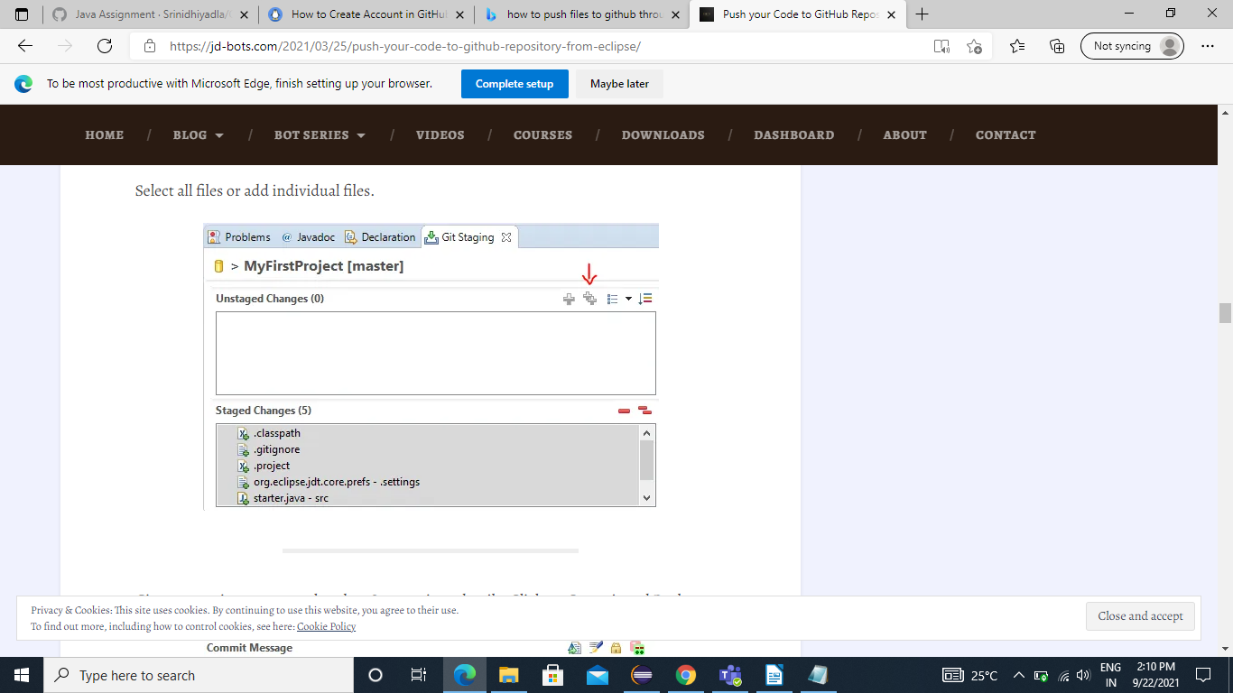

Step 9: Give a commit message and author & committer details. Click on Commit and Push.
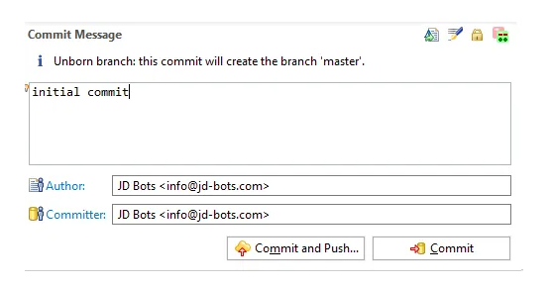

Step 10: Paste the GitHub Repository URI. The host and repository path will be auto-populated. If the GitHub repo is private, provide the username and password in the required fields.
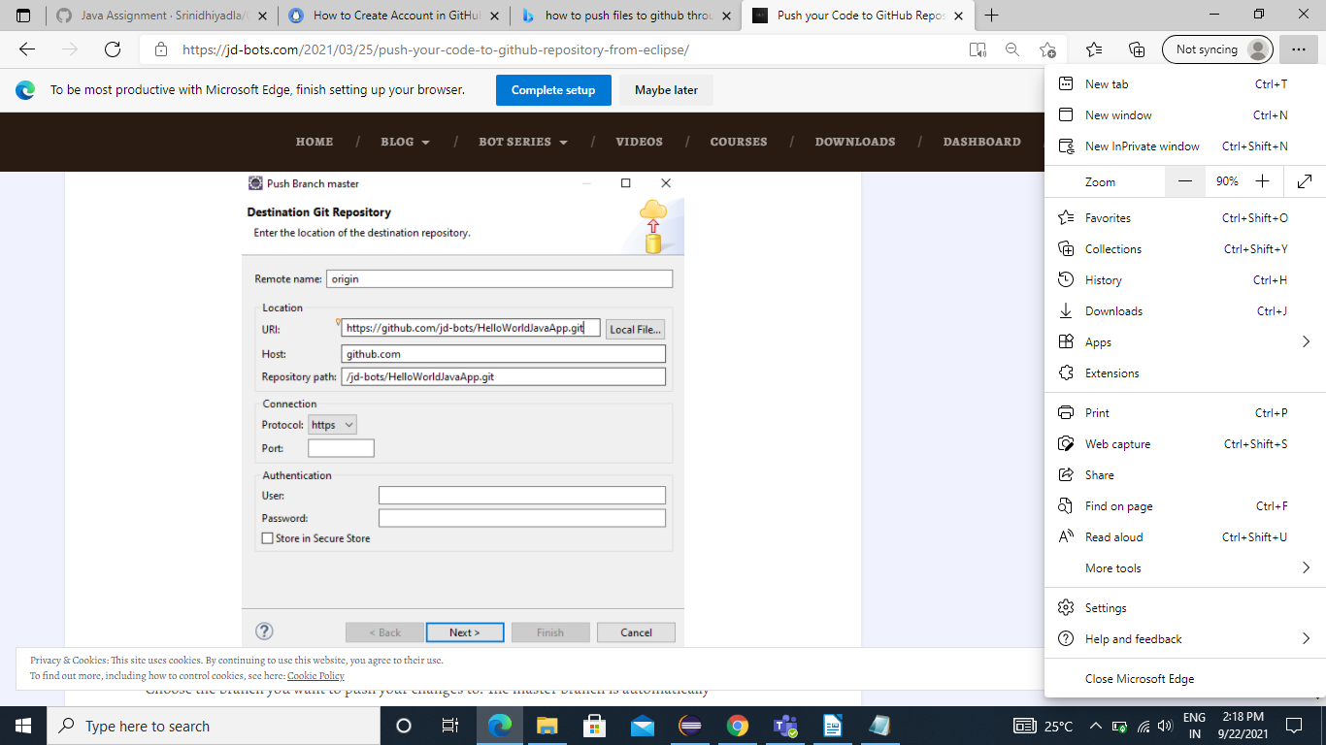

Step 11: Select the branch you want to push your changes to. And click on next.
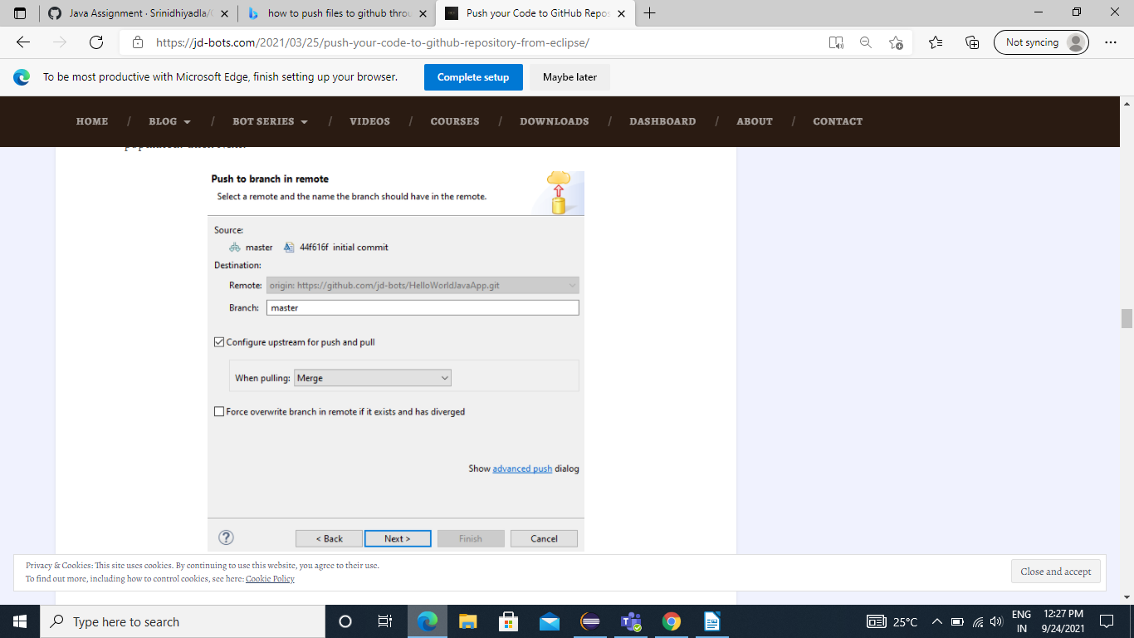

Step 12: Login to GitHub to push your changes and click on finish.
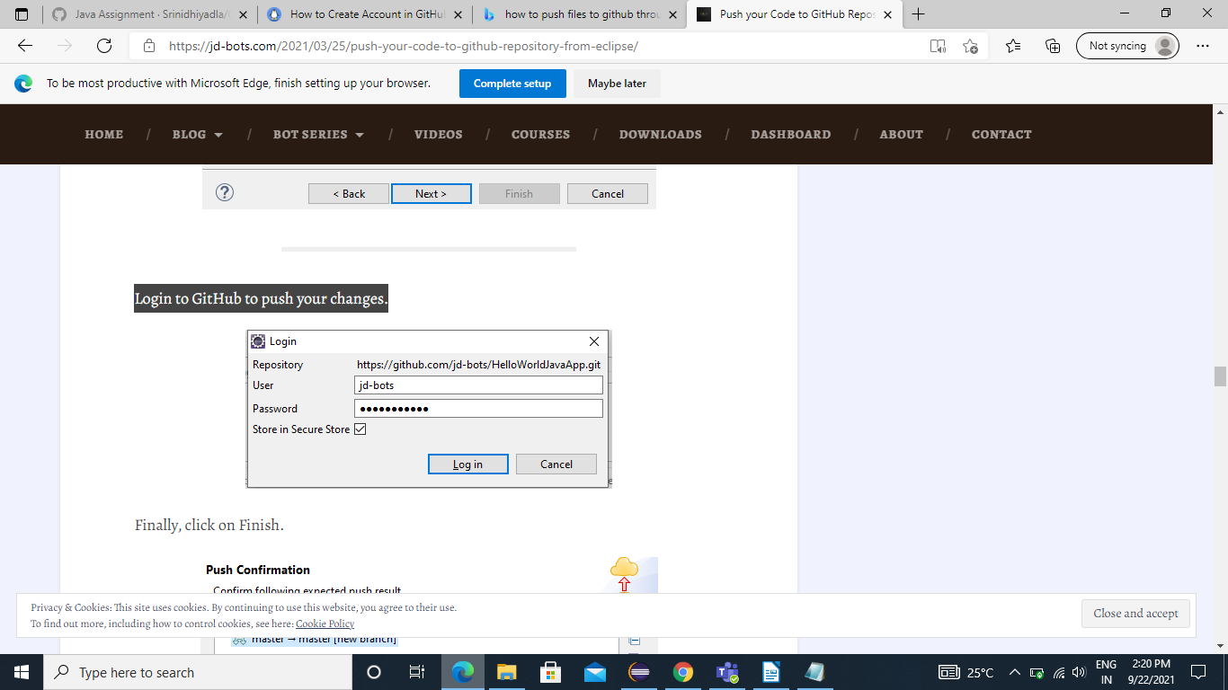

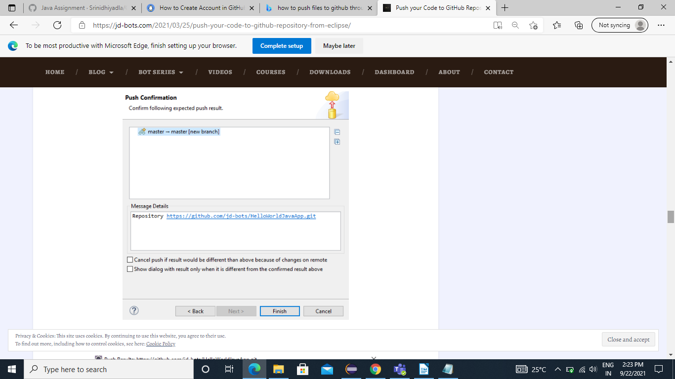

Step 13: Finally changes to the GitHub from Eclipse is done
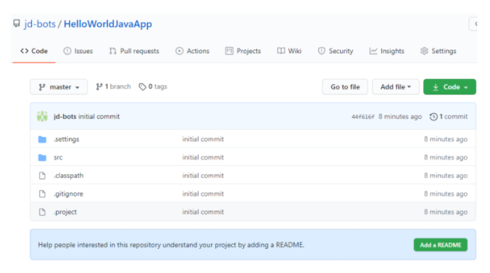

Performance of Pull Operation in Eclipse
Step 1: Right click on your repository and select the appropriated operation.
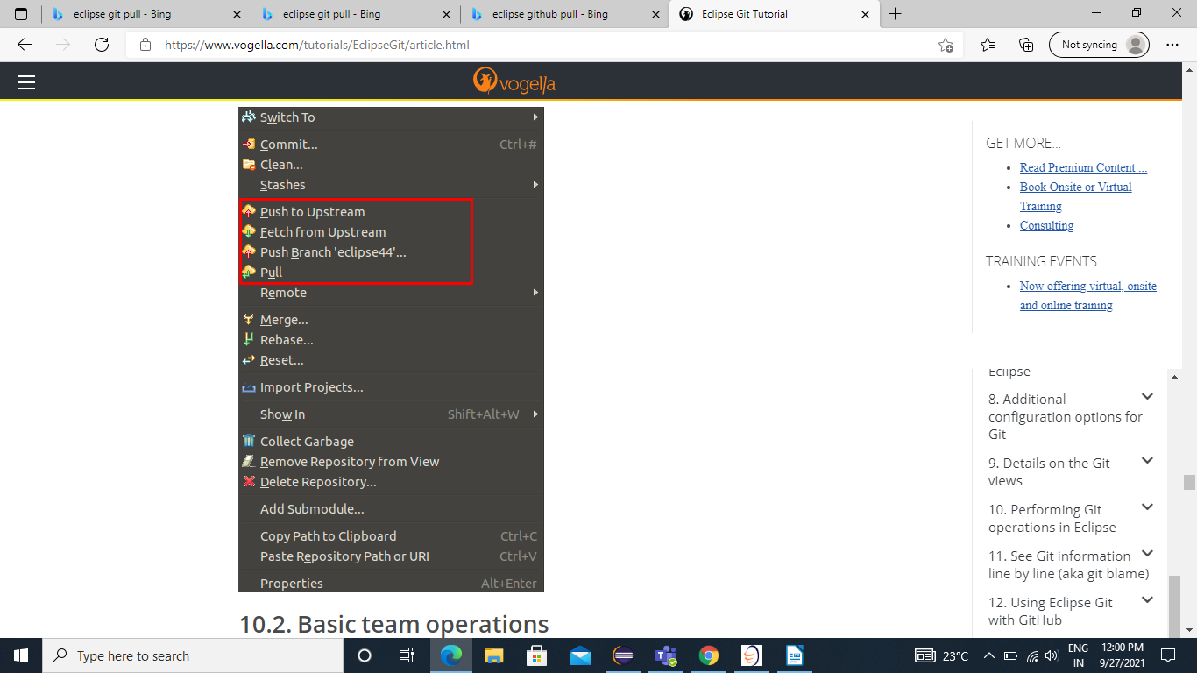

Step 2: Right-click on your project or file If you select a project you can use pull operations from the context menu.
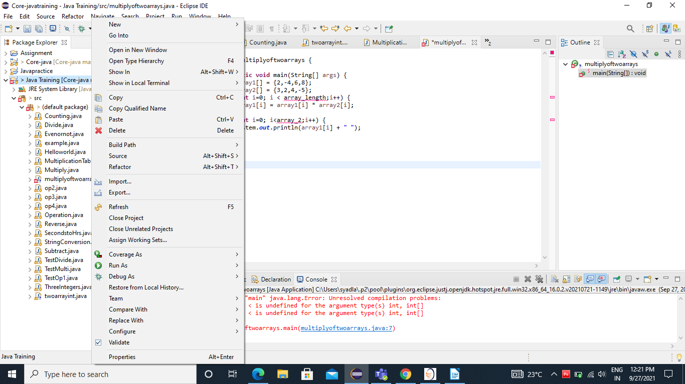

Step 3: Now click on Team< select Pull to pull in changes from your remote Git repository
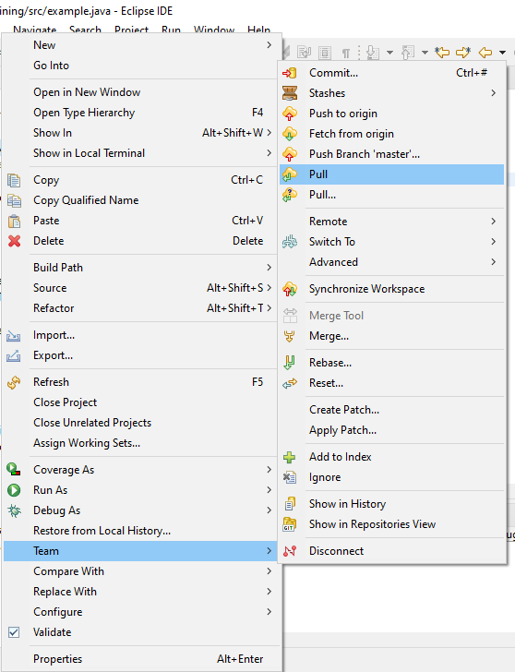

Synchronize the local repository with Github

Step 1: Go to the GitHub official website and make sure you are logged in


Step 2: In the top right corner, click on + sign and then click New repository
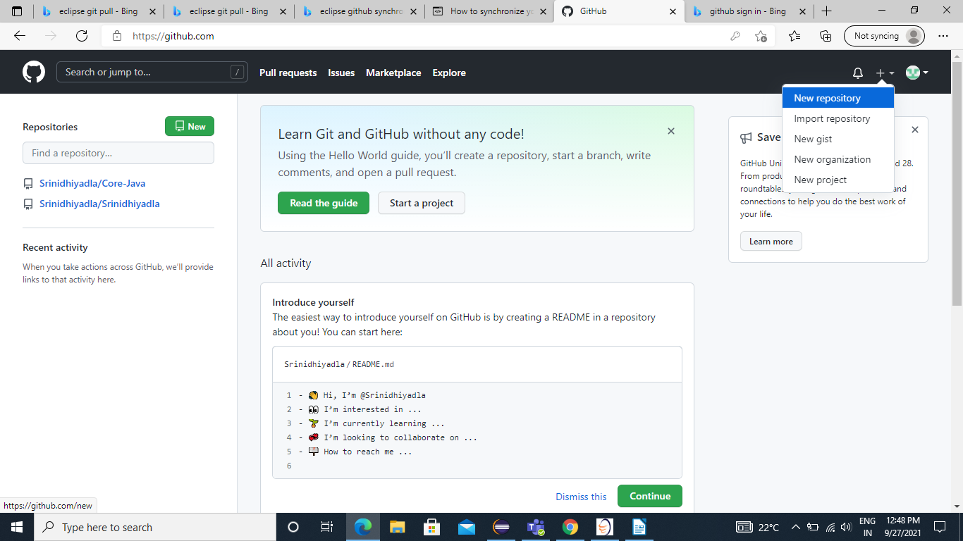

Step 3: Enter the name of your repository.
- Add a description of your repository something like “ first git project”
- Click the button to create the repository.

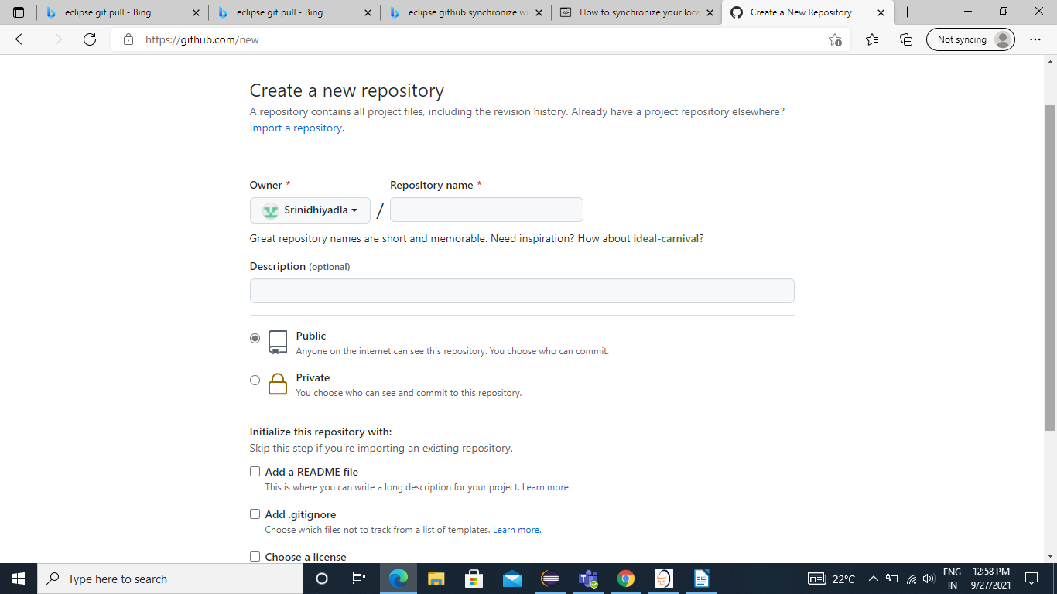

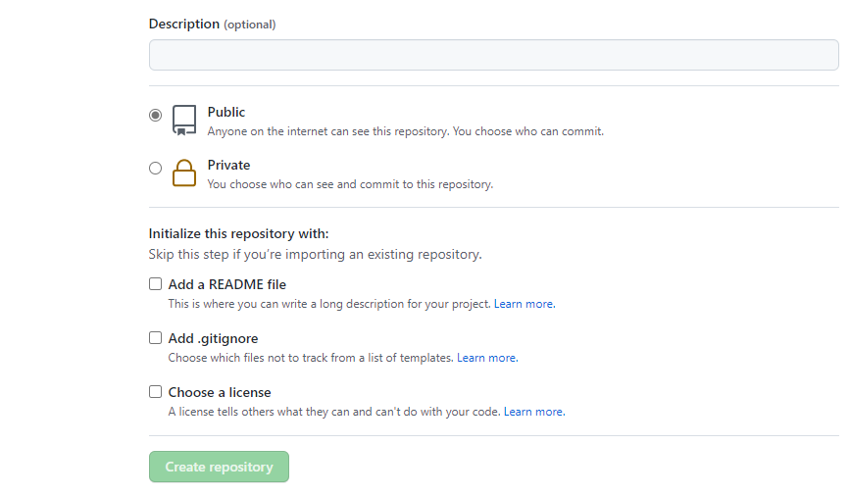

These steps have created an empty repository on GitHub; you now need to synchronize your local repository with GitHub.

